Staff Profile

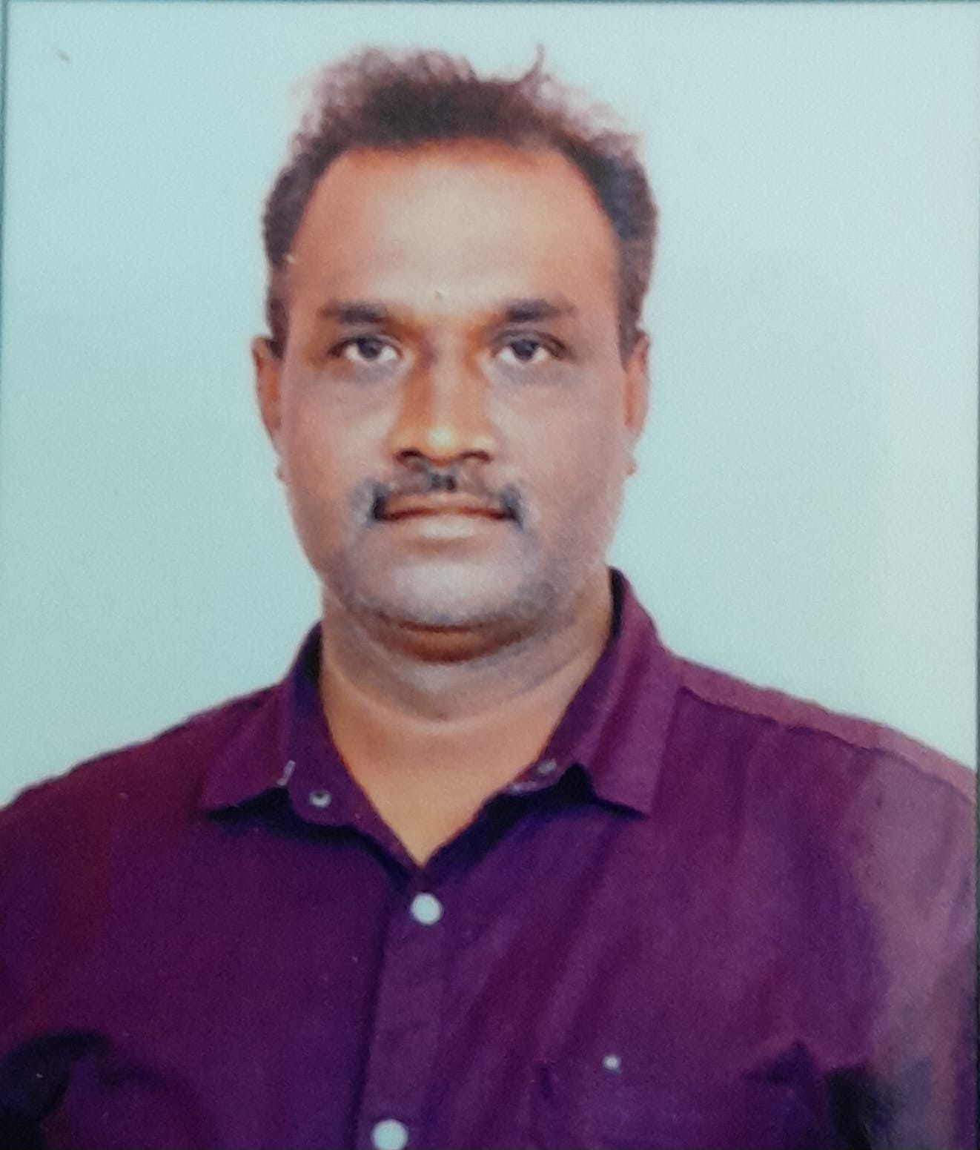

Name : Dr. Sekar V
Designation : Guest Lecturer
Department : Public Administration
DateofBirth : 21.04.1983
Date of Joining Collegiate
Service : 18.01.2023
Date of Joining Govt. Collegiate Service: --Mobile No : 9159707927
Email-Id: sekarmku@gmail.com
Educational Qualifications :M.A., M.Phil., Ph.D.,
Experience: UG: 7 years
PG: 2 years
Research Experience : Nil

Publications:
Journals:07
Conferences:23
Research Projects: Nil GuideshipM.Phil. / Ph.D ; Nil Workshop/Seminar/symposium attended:
Workshop 3
Seminar 5
Area of Interest : Adminitration, Urban and Local Government
Resource Persons :Nil
Books Published : Nil Membership in professional bodies :Nil Others: Nil

