Staff Profile

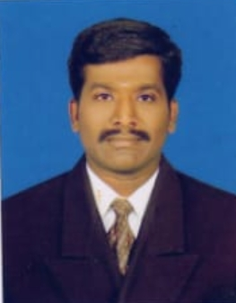

PHOTO
Name : Dr. M. PRABHU
Designation : Guest Lecturer
Department : Social work
Date of Birth : 21/09/1985
Date of Joining : 17/08/2016
Date of Joining Govt. Collegiate Service: 17/08/2016
Mobile No : 9095333367
Email-Id : prabhu21985@gmail.com
Educational Qualifications : MSW, M.Phil., Phd.
Experience: PG: 10 Yrs. 1 Month.
Research Experience : Nil
Publications : Journals:0 Conferences:0
Research Projects : Nil
Guideship M.Phil. / PhD ; Nil
Workshop/Seminar/symposium attended: Workshop 0 Seminar 0
Area of Interest : Marketing Management
Resource Persons : Nil
Books Published : Nil
Membership in professional bodies: Nil
Others : Nil

