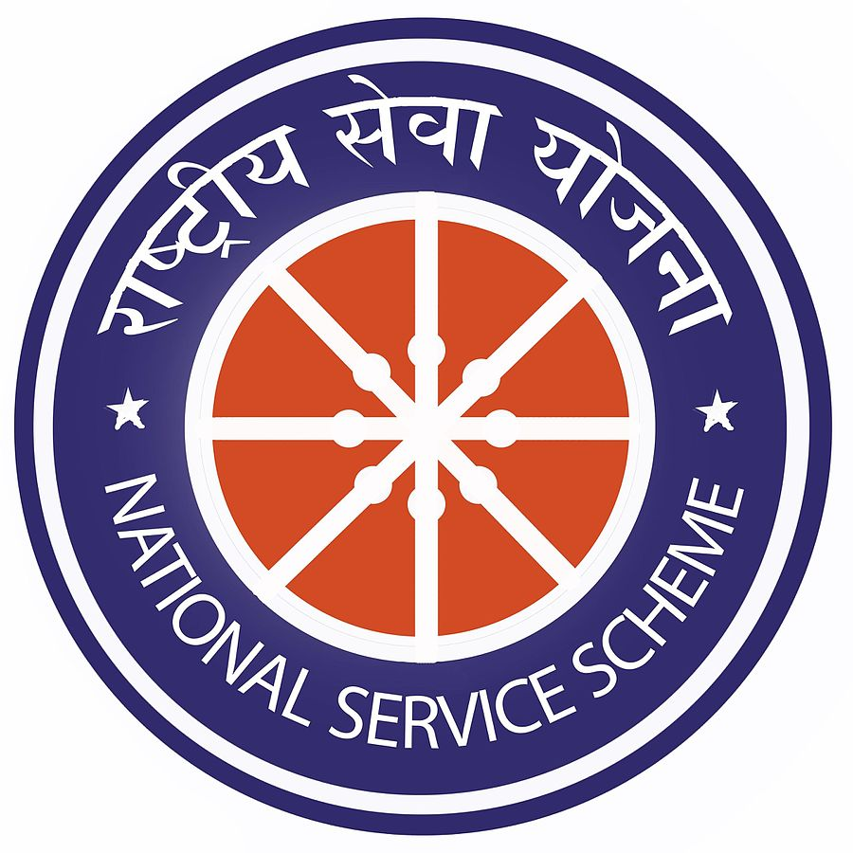
Not me But You
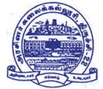
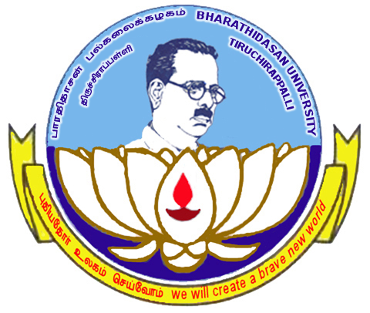

GOVERNMENTARTSCOLLEGE,TRICHY–620022
NATIONALSERVICESCHEME -2022-23
AffiliatedtoBharathidasanUniversity-Trichy
__________________________________________________________________________________
NSS 2022-2023 ACTIVITIES

- 06-04-2022 Campus Cleaning

- 11-08-2022Drug abuse awareness program

- 15-08-2022Flag Hoisting

- 18-08-2022Food safety awareness program

- 18-08-2022sarthar vallabai Patel pledge

- 26-08-2022Women and Children Safety Awareness program

- 27-08-2022Bank Account Opening rally

- 27-08-2022Bank Account Opening rally

- 23-09-2022Rain water harvesting

- 29-09-2022NSS officers meeting

- 30-09-2022Campus Cleaning

- 30-09-2022NSSorientation program

- 12-10-2022SwachchBharath mission 2.0

- 19-10-2022Clean India Drive 2.0

- 21-10-2022 Eye Check-up camp

- 27-10-2022Blood donation camp

- 28-10-2022Road safety awareness rally

- 31-10-2022National Integrity Day

- 31-10-2022Free Medical Check-up camp for Sugar and BP

- 08-02-2023 “Vetri Nichayam” movie screened in Auditorium

- 22-02-2023 Medical camp in search of “HEALTH MELA” Govt.of

Tamilnadu Health Department

NAME OF THE PROGRAME :Campus Cleaning
NUMBEROF PARTICIPATIONS:40 students
Date:06-04-2022
PROGRAMEOrganizer:Dr.J.THOMASJOSEPHPRAKASH,PO-UNIT-II

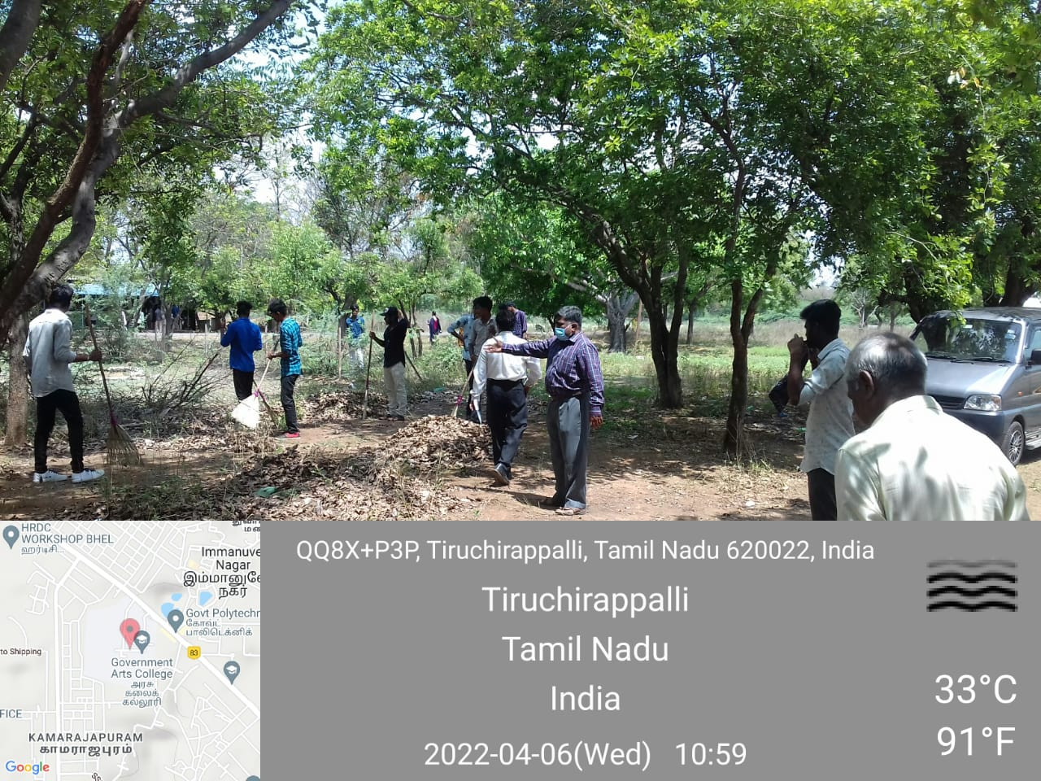

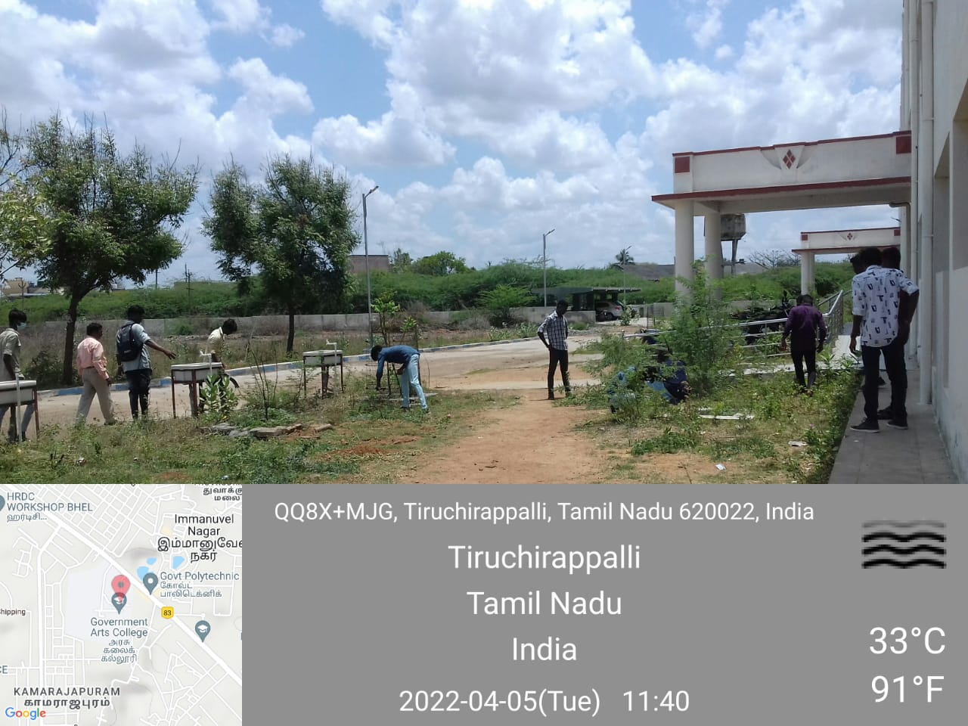

NAMEOFTHEPROGRAME:Chess olympiod
NUMBEROF PARTICIPATIONS: 40
Date:27-07-2022
PROGRAMEOrganizer:Dr.J.THOMASJOSEPHPRAKASH,PO-UNIT-II
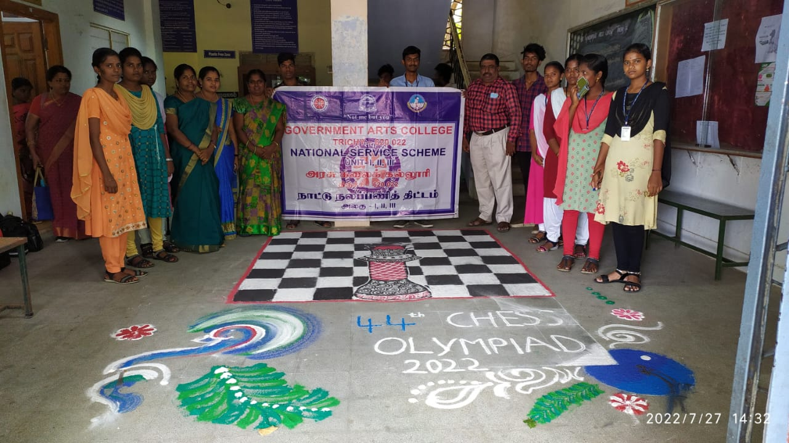

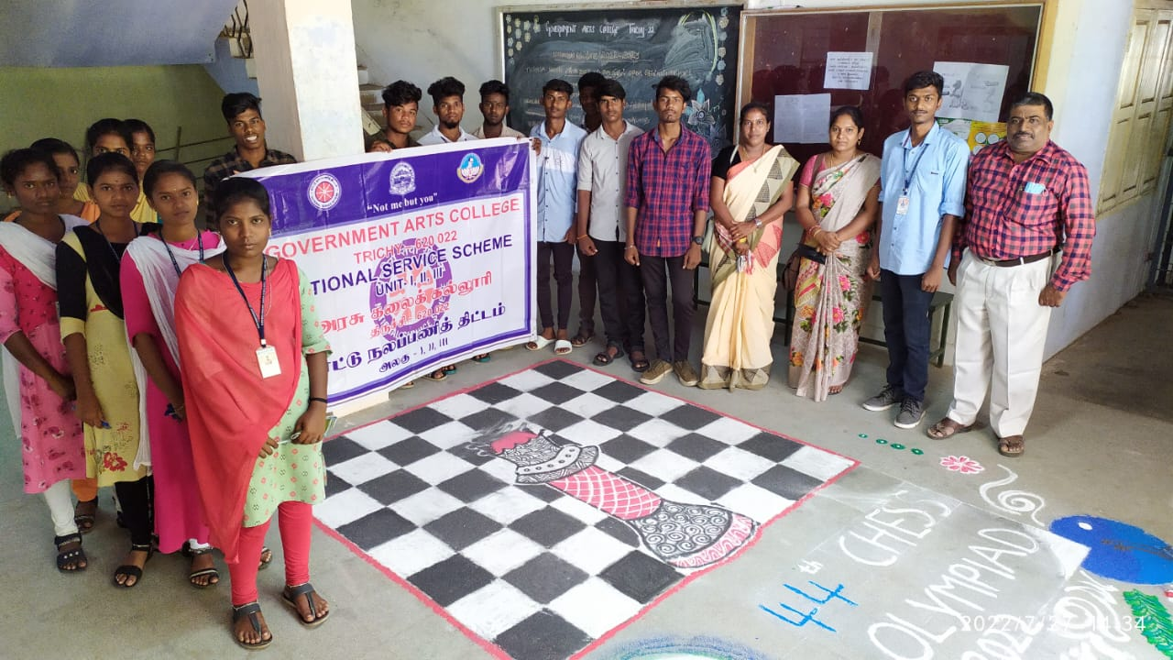

NAMEOFTHEPROGRAME:Drug abuse awareness program
NUMBEROF PARTICIPATIONS:400
Date:11-08-2022 and 13.08.2022
PROGRAME Organized by Trichy district collector, and participated by NSS – GAC, Trichy - 22

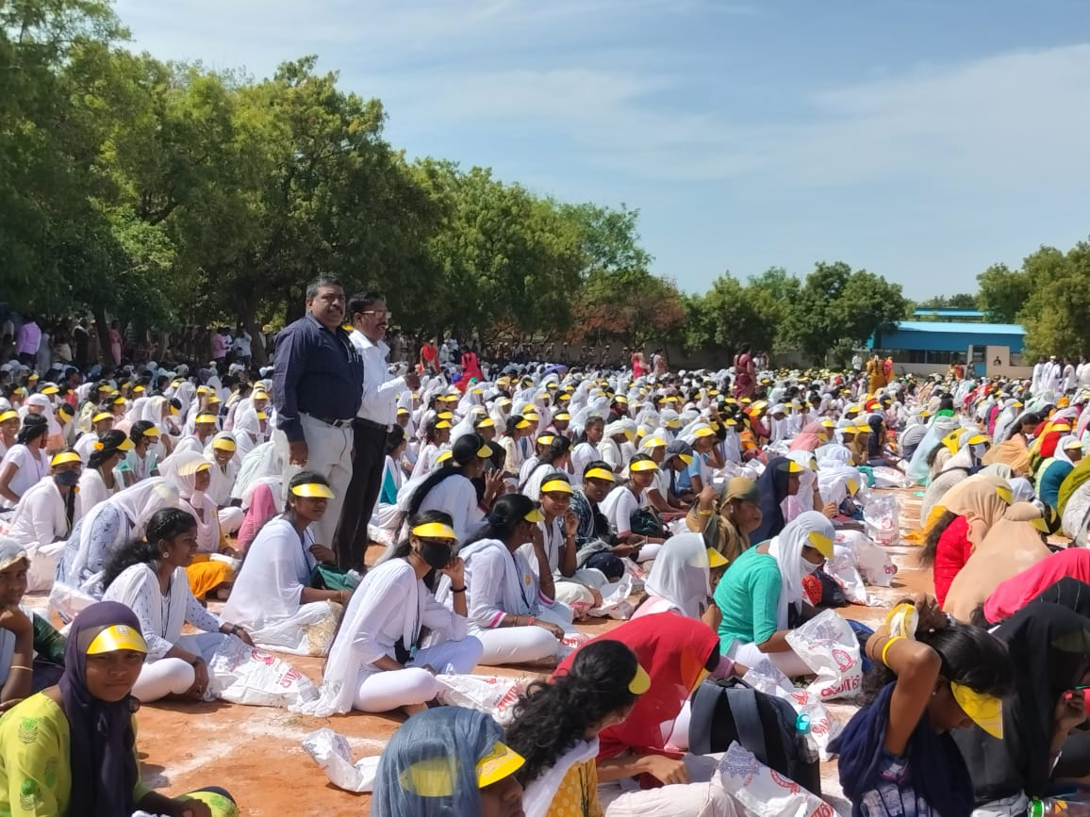

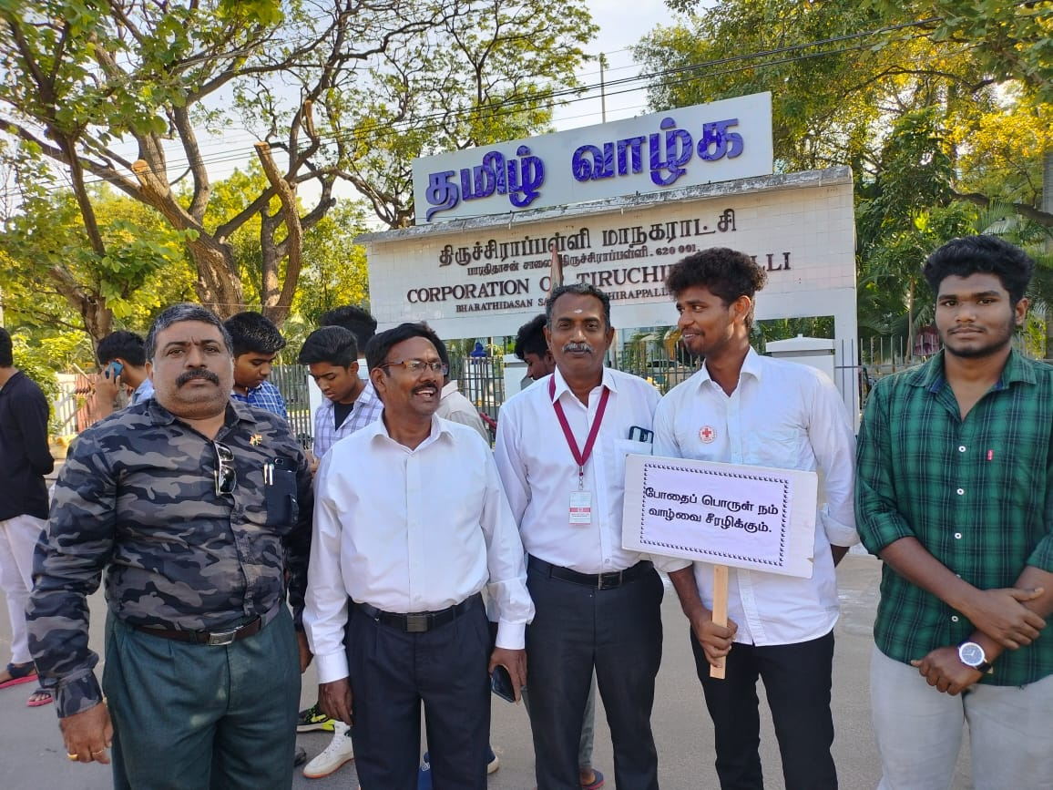

NAMEOFTHEPROGRAME: National flag distribution
NUMBEROF PARTICIPATIONS: 30
Date:13-08-2022
PROGRAMEOrganizer:Dr.J.THOMASJOSEPHPRAKASH,PO-UNIT-II

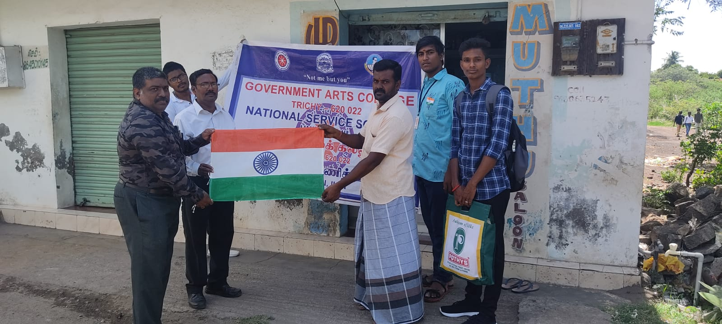

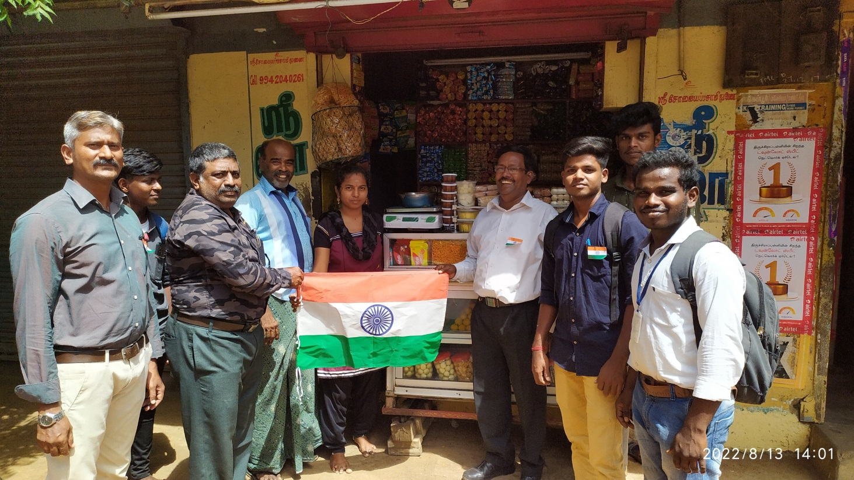

NAME OF THE PROGRAME:Flag Hoisting – Independence Day
NUMBEROF PARTICIPATIONS: 200
Date:15-08-2022
PROGRAMEOrganizer:Dr.J.THOMASJOSEPHPRAKASH,PO-UNIT-II

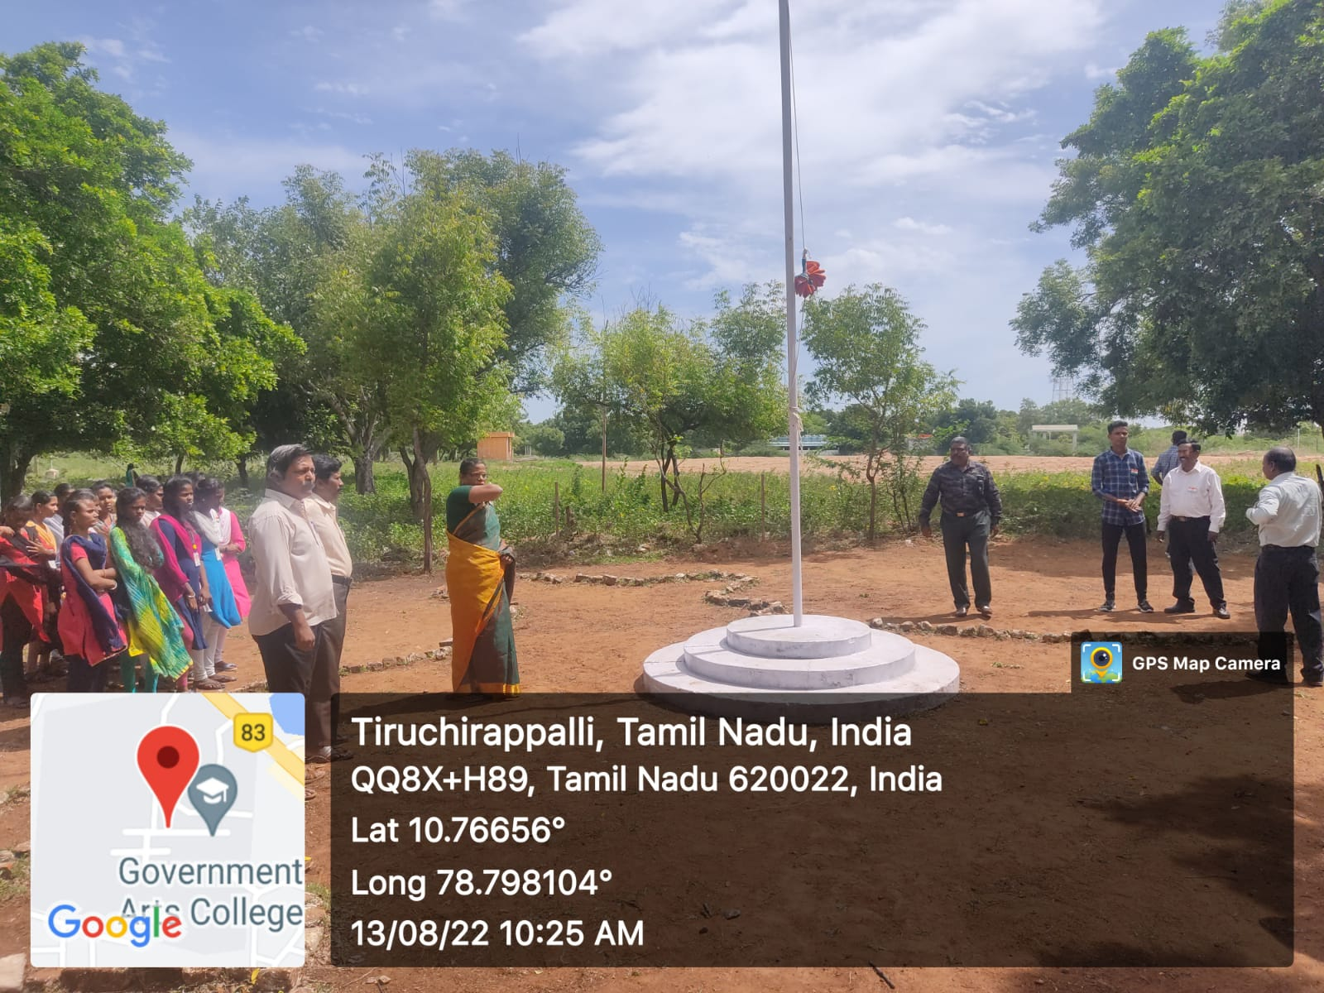

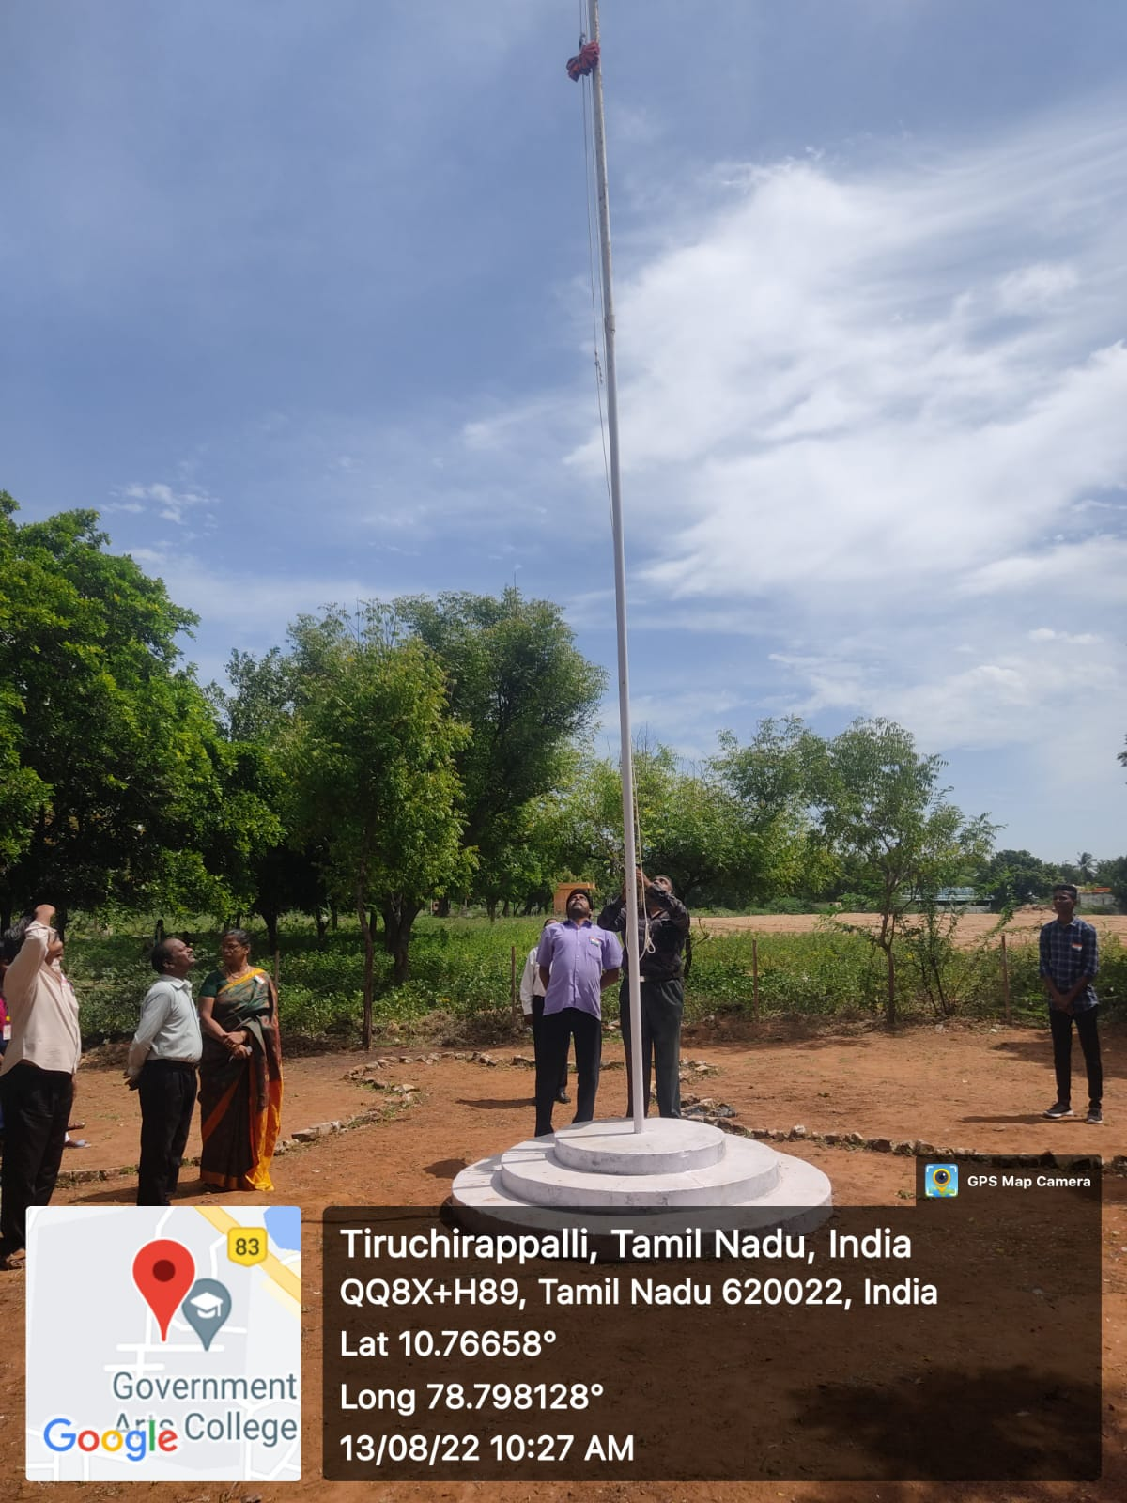

NAME OF THE PROGRAME:Sartharvallabai Patel Pledge.
NUMBEROF PARTICIPATIONS:
Date:18-08-2022
PROGRAMEOrganizer:Dr.J.THOMASJOSEPHPRAKASH,PO-UNIT-II

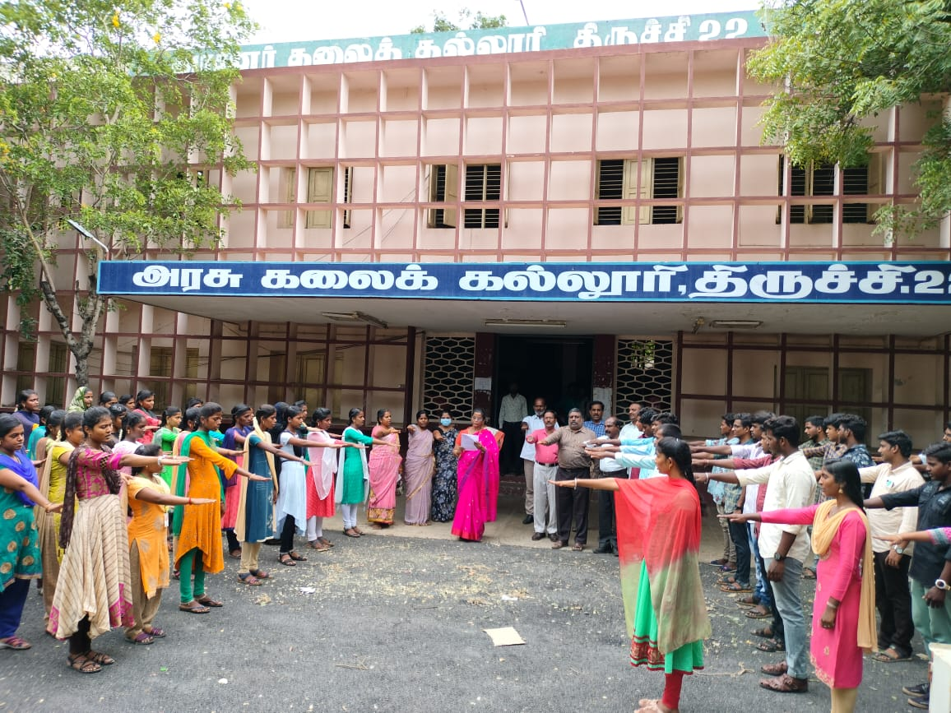

NAME OF THE PROGRAME:Women and Children Safety Awareness Program.
NUMBEROF PARTICIPATIONS: 600
Date:26-08-2022
Dr.J.THOMASJOSEPHPRAKASH,PO-UNIT-II
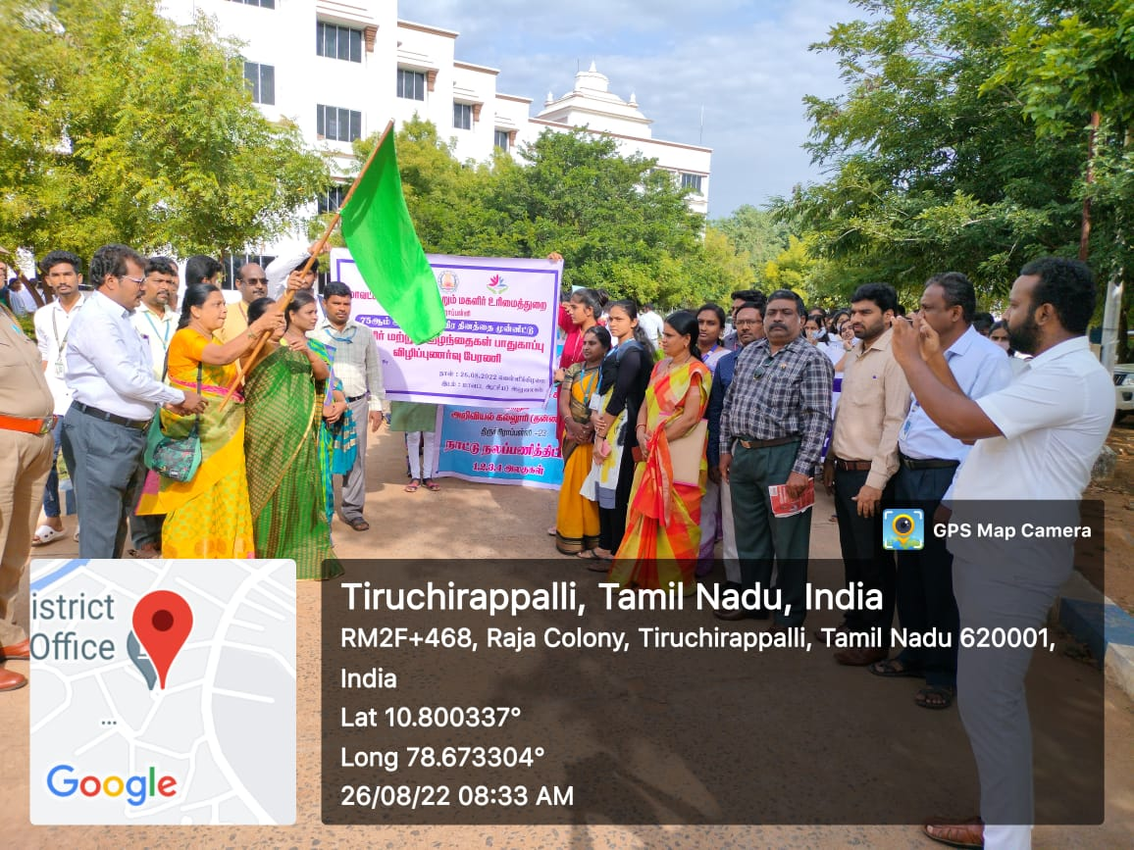

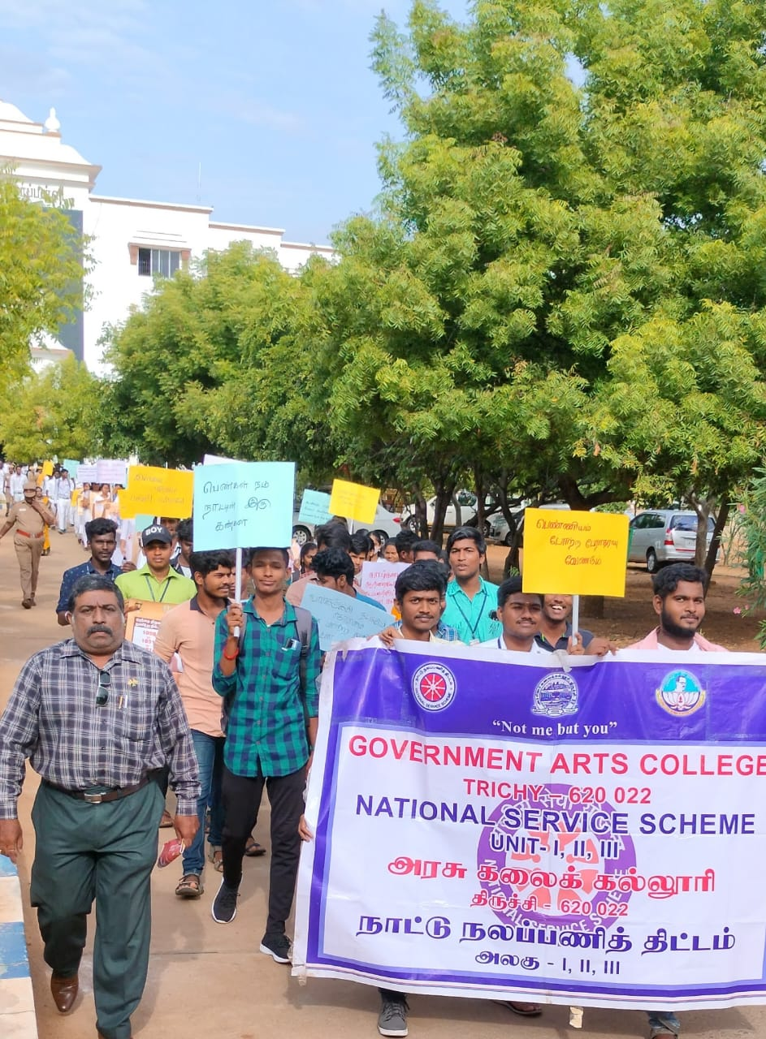

NAME OF THE PROGRAME: Bank Account Opening day For First year Students.
NUMBEROF PARTICIPATIONS: 200
Date:27-08-2022
PROGRAMEOrganizer:Dr.J.THOMASJOSEPHPRAKASH,PO-UNIT-II

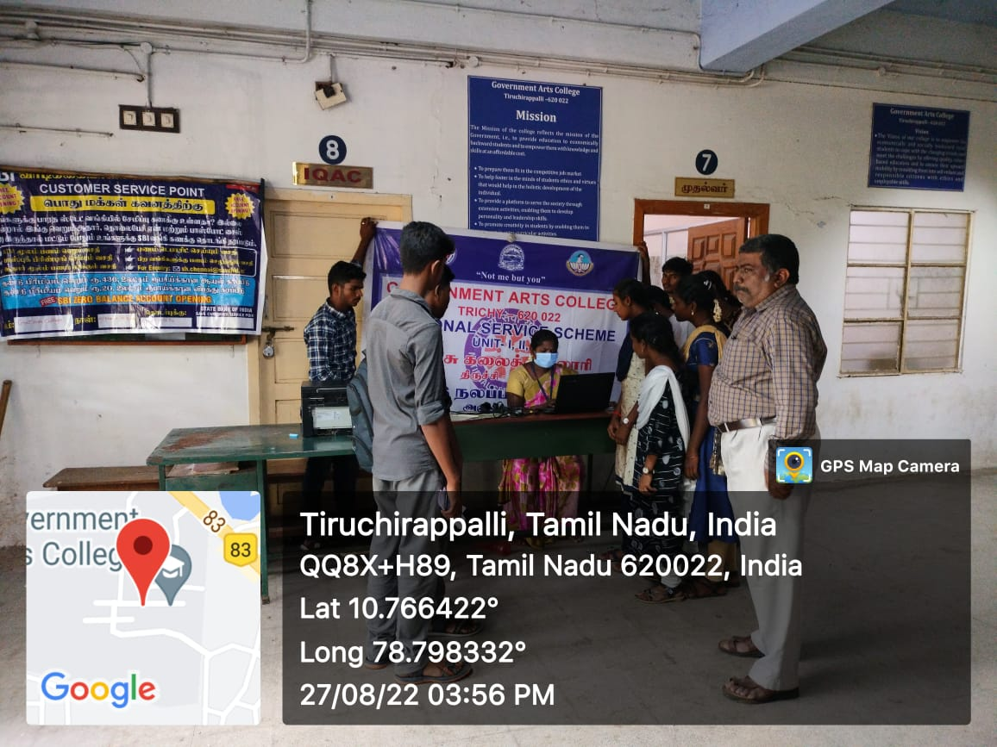

NAME OF THE PROGRAME: Campus Cleaning.
NUMBEROF PARTICIPATIONS: 50
Date:27-08-2022
PROGRAMEOrganizer:Dr.J.THOMASJOSEPHPRAKASH,PO-UNIT-II

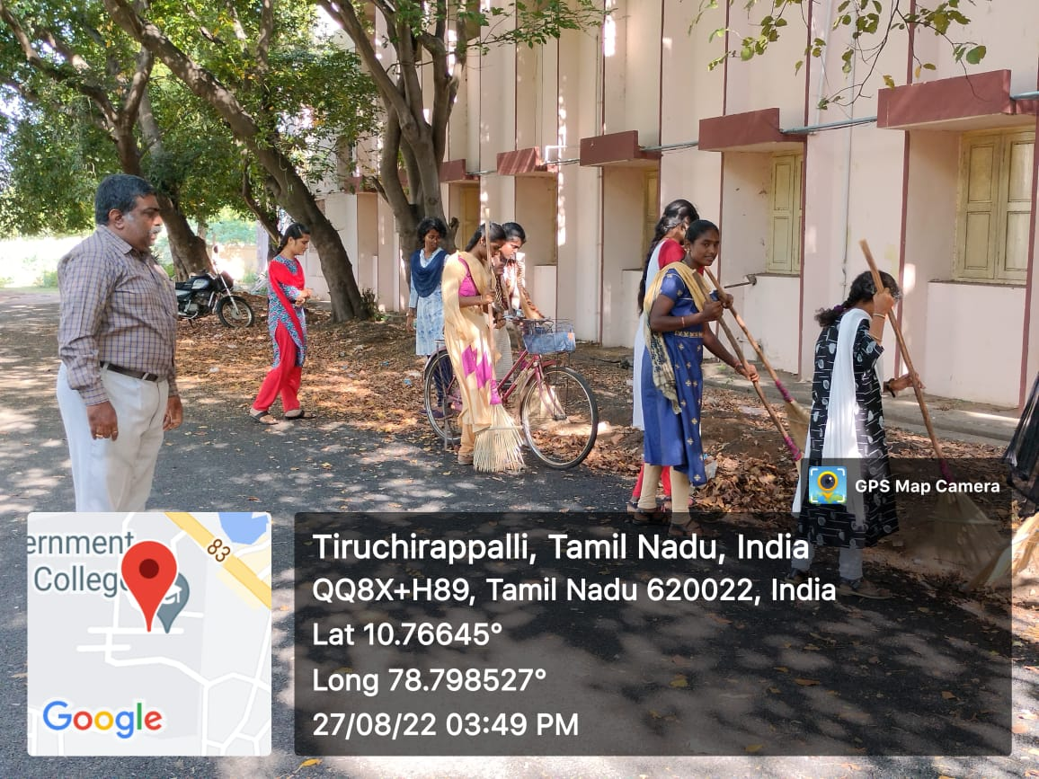

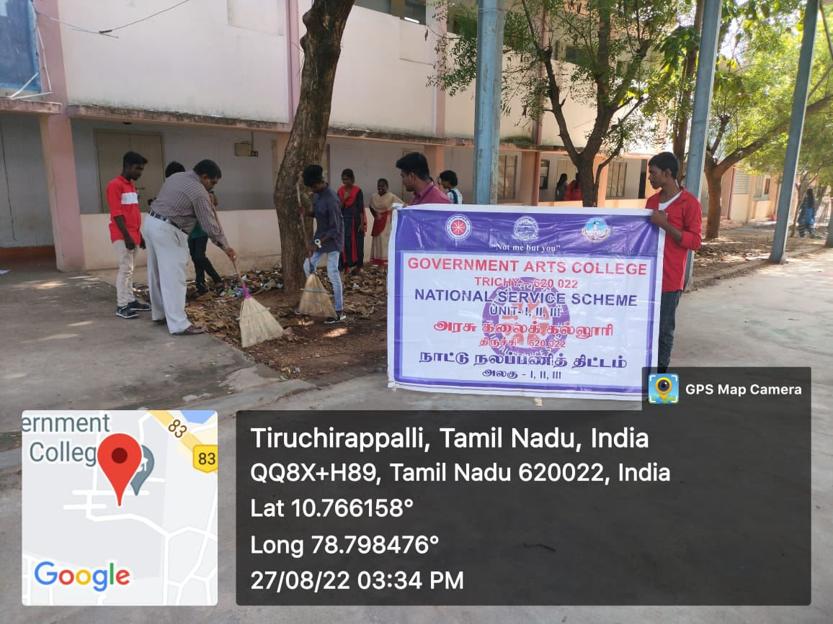

NAME OF THE PROGRAME: Rain water Harvesting Awareness Rally.
NUMBEROF PARTICIPATIONS: 300
Date:23-09-2022
PROGRAMEOrganizer:Dr.J.THOMASJOSEPHPRAKASH,PO-UNIT-II

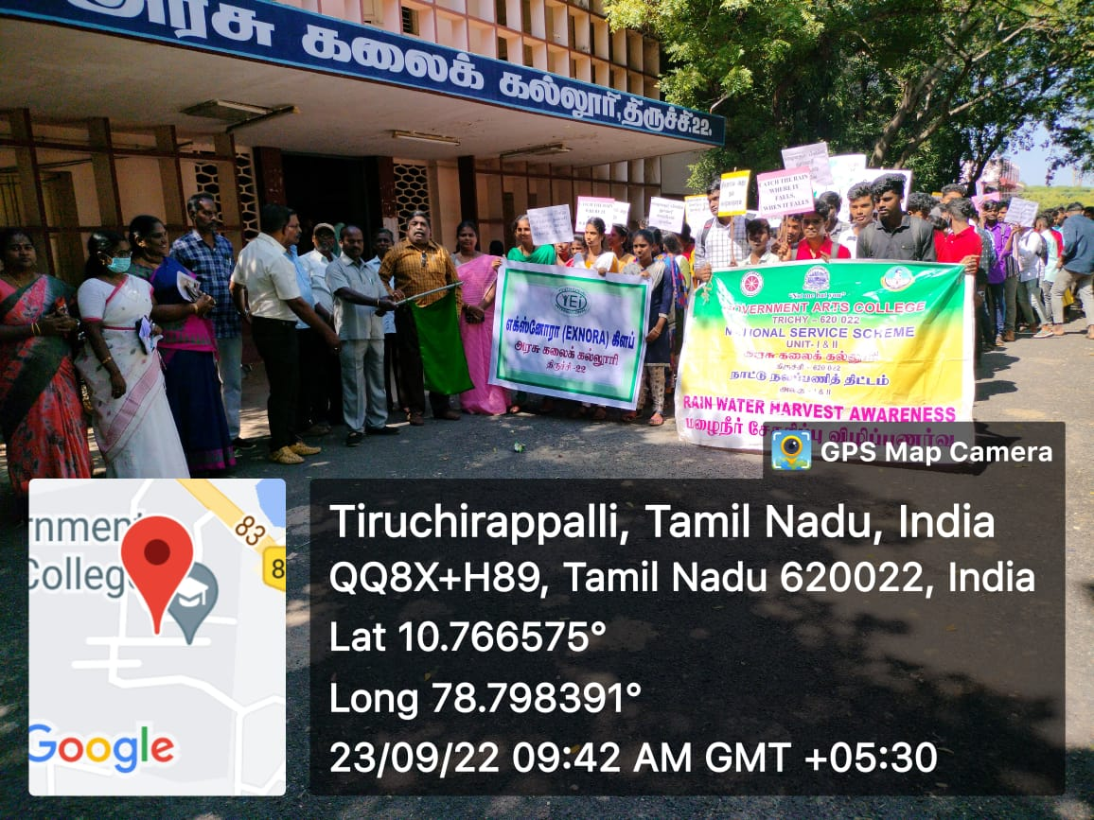

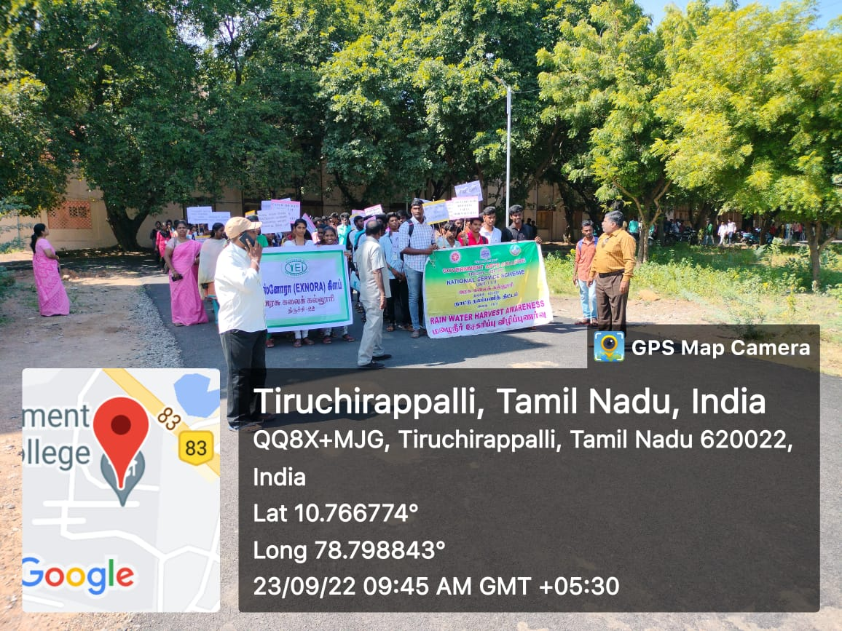

NAME OF THE PROGRAME: NSS officers meeting
NUMBEROF PARTICIPATIONS:
Date:29-09-2022
Dr.J.THOMASJOSEPHPRAKASH,PO-UNIT-II

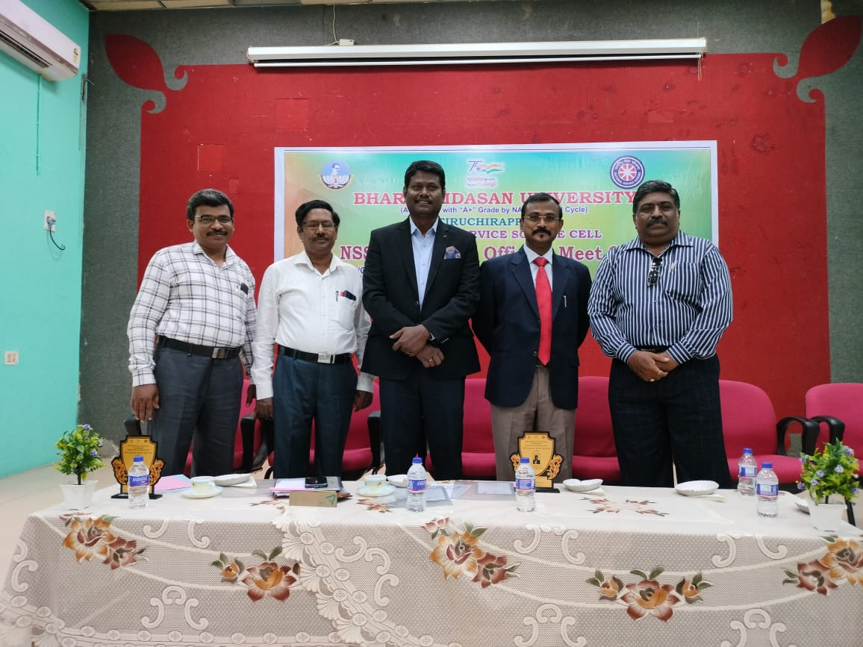

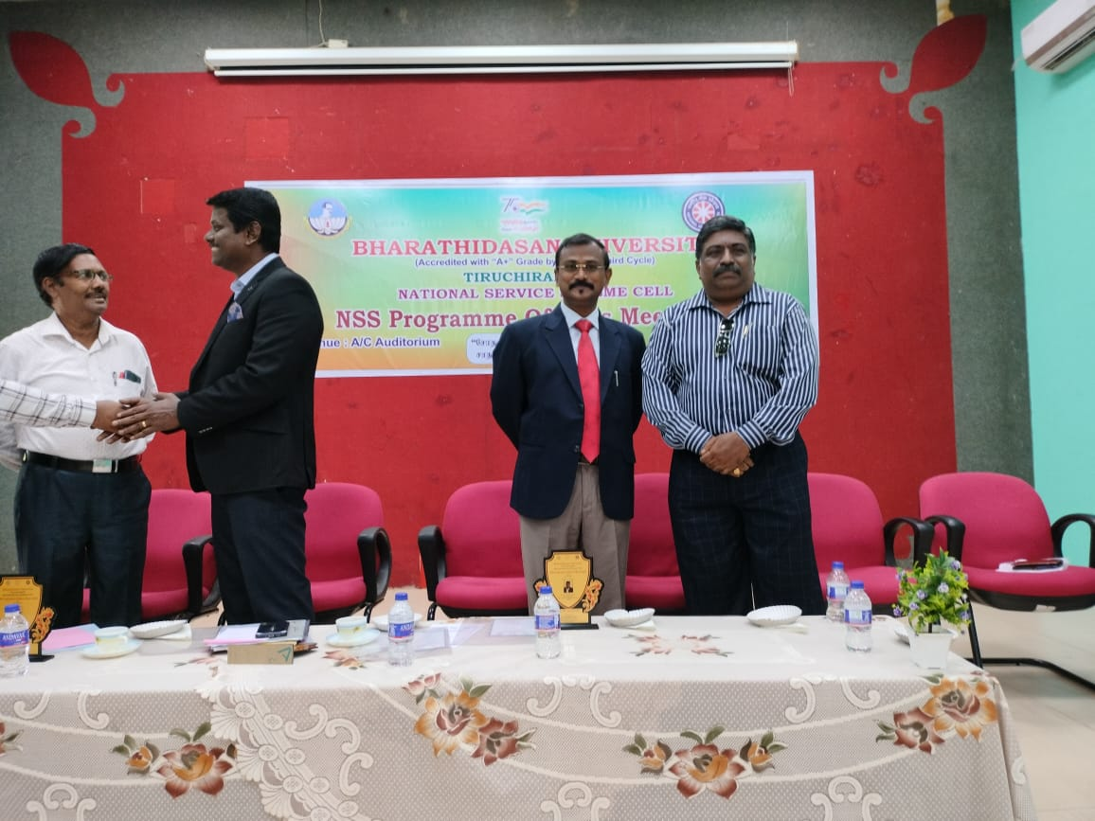

PROGRAMEOrganizer:Dr.J.THOMASJOSEPHPRAKASH,PO-UNIT-II
NAME OF THE PROGRAME: campus cleaning
NUMBEROF PARTICIPATIONS: 30
Date:30-09-2022
PROGRAMEOrganizer:Dr.J.THOMASJOSEPHPRAKASH,PO-UNIT-II
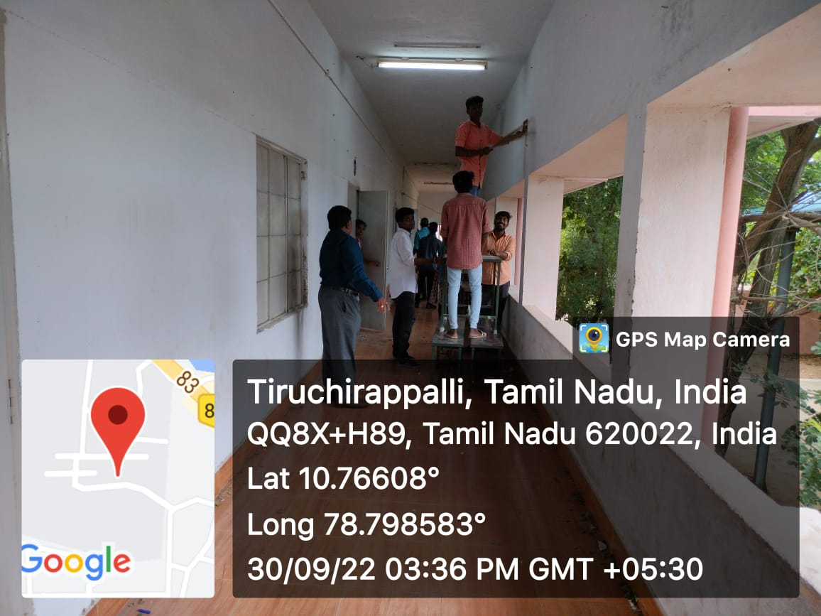

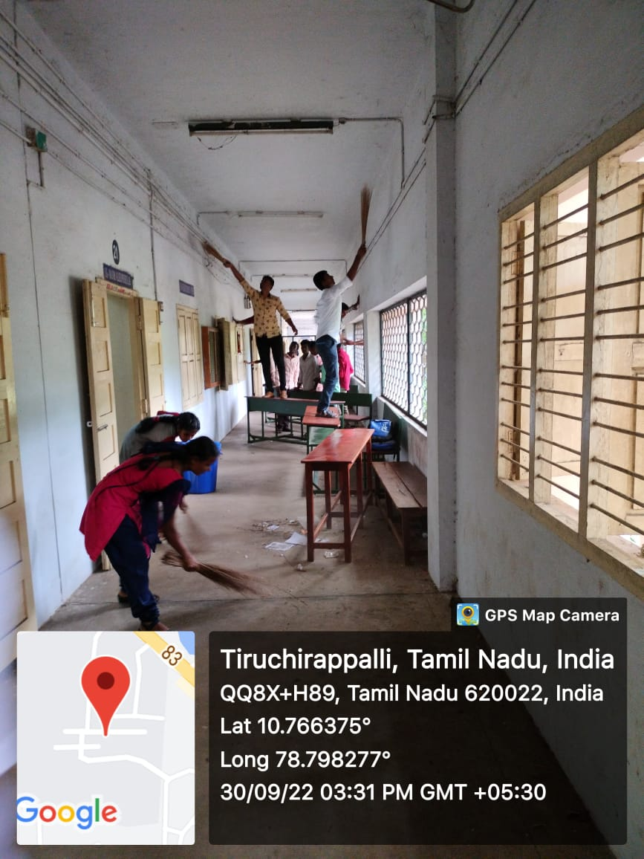

NAME OF THE PROGRAME:NSS orientation program
NUMBEROF PARTICIPATIONS: 150
Date:30-09-2022
PROGRAMEOrganizer:Dr.J.THOMASJOSEPHPRAKASH,PO-UNIT-II
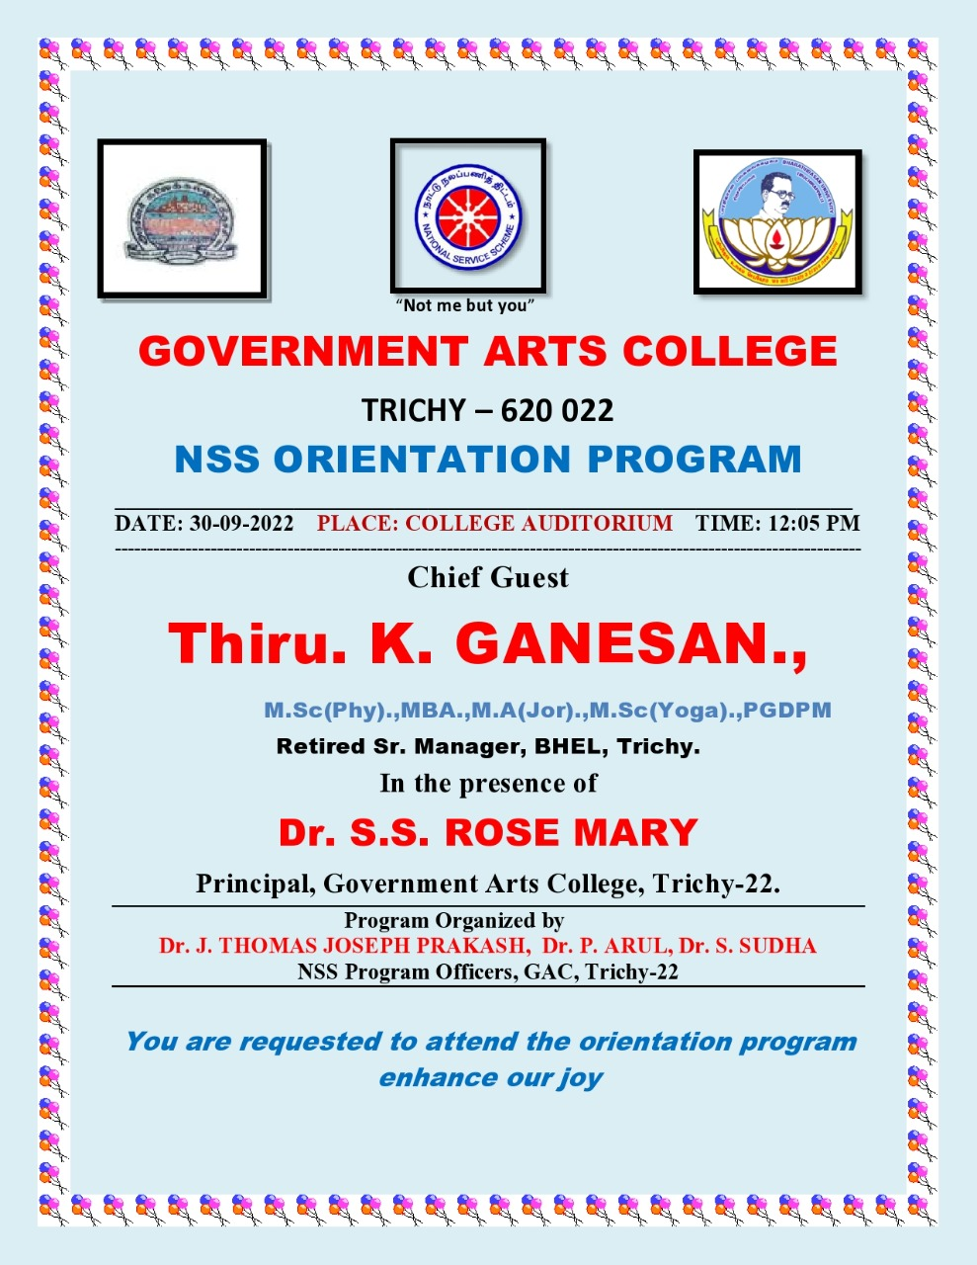

NAME OF THE PROGRAME: SwachchBharath Mission 2.0
NUMBEROF PARTICIPATIONS:
Date:12-10-2022
PROGRAMEOrganizer:Dr.J.THOMASJOSEPHPRAKASH,PO-UNIT-II

NAME OF THE PROGRAME: clean india drive 2.0
NUMBEROF PARTICIPATIONS:
Date:19-10-2022
PROGRAMEOrganizer:Dr.J.THOMASJOSEPHPRAKASH,PO-UNIT-II
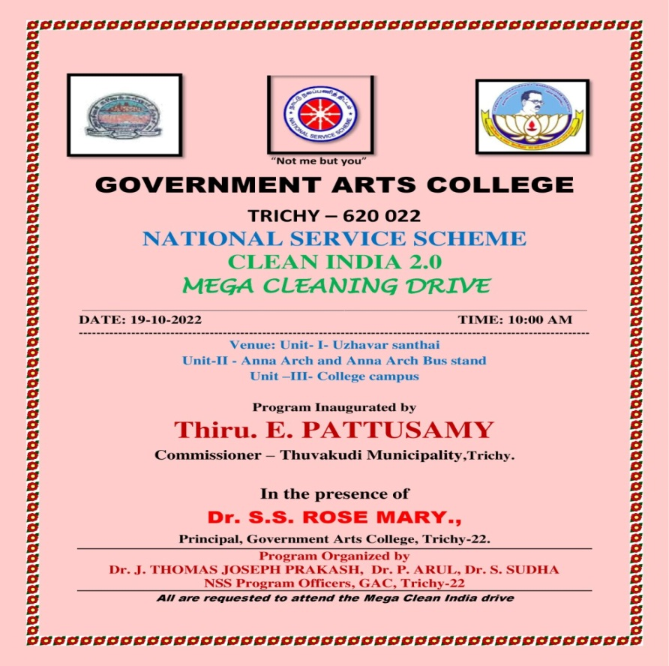

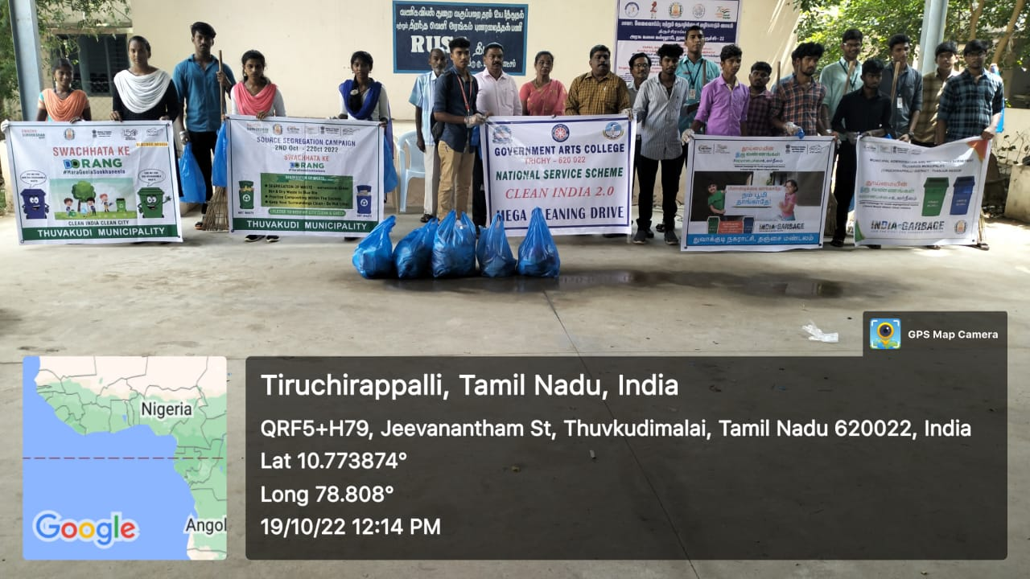

NAME OF THE PROGRAME: Eye Check-up Camp
NUMBEROF PARTICIPATIONS: 550
Date:21-10-2022
PROGRAMEOrganizer:Dr.J.THOMASJOSEPHPRAKASH,PO-UNIT-II
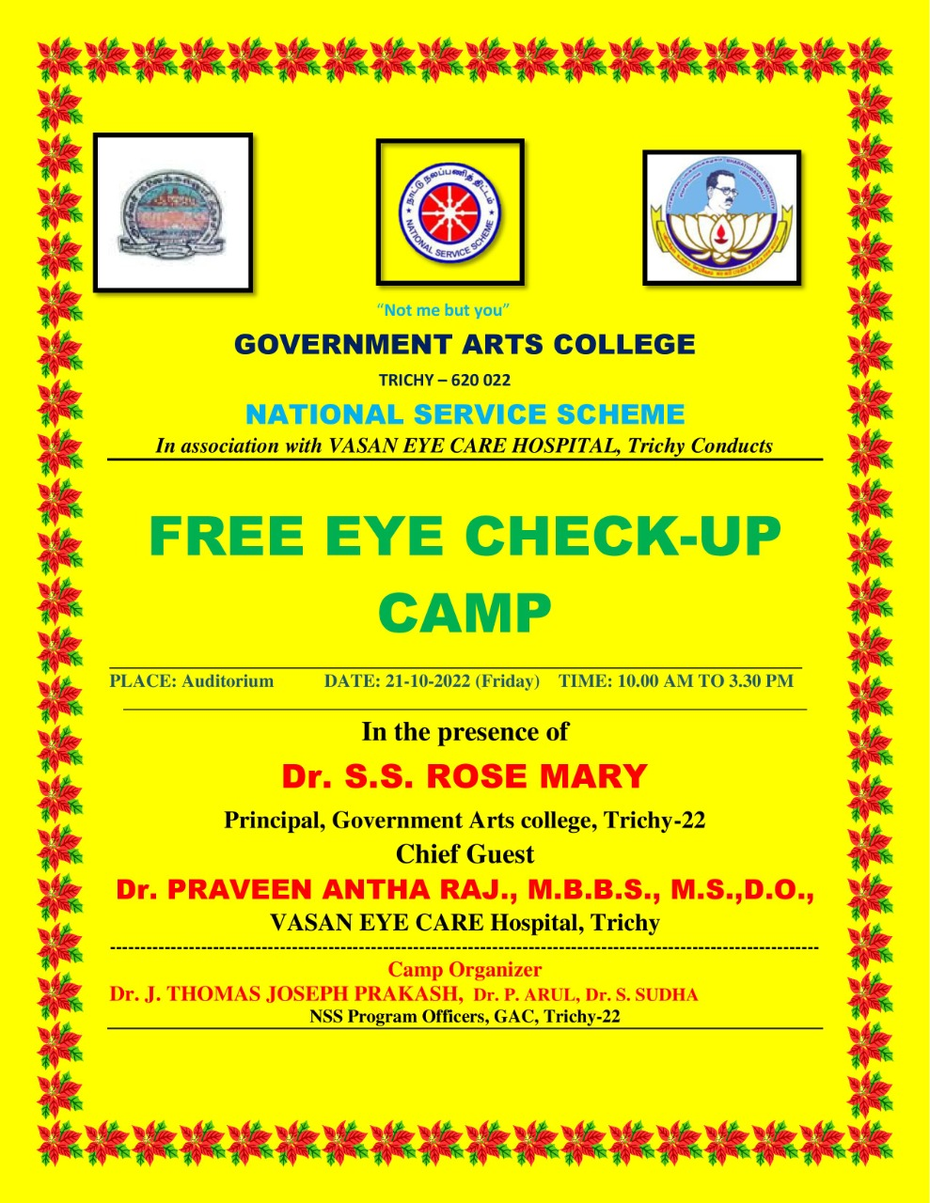
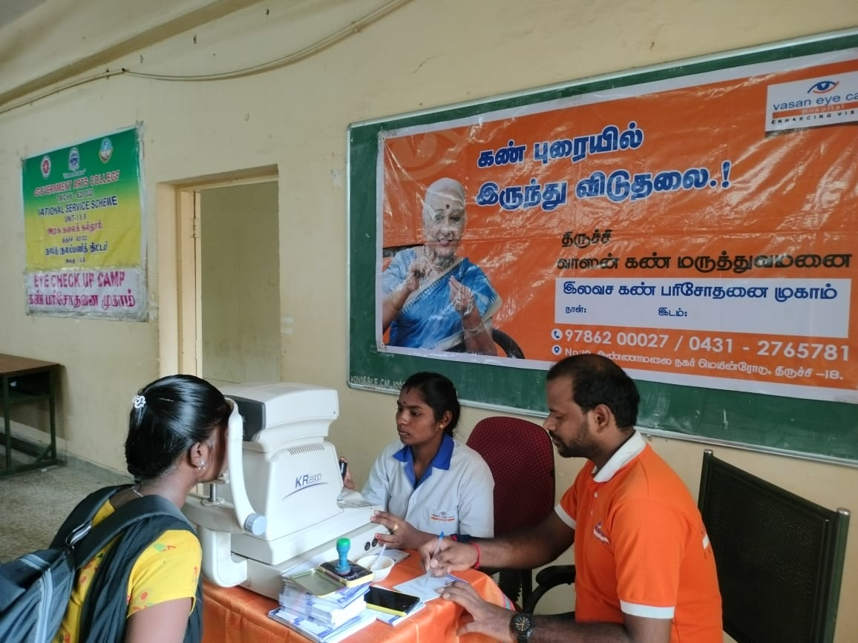
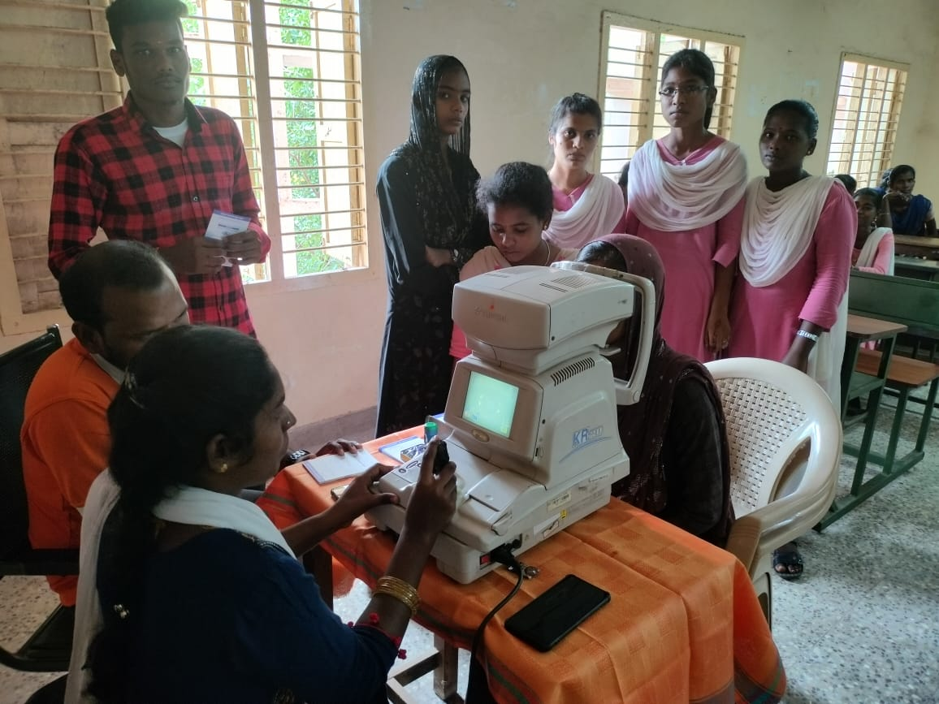

NAME OF THE PROGRAME: Blood donation camp
NUMBEROF PARTICIPATIONS: 55
Date:27-10-2022
PROGRAMEOrganizer:Dr.J.THOMASJOSEPHPRAKASH,PO-UNIT-II
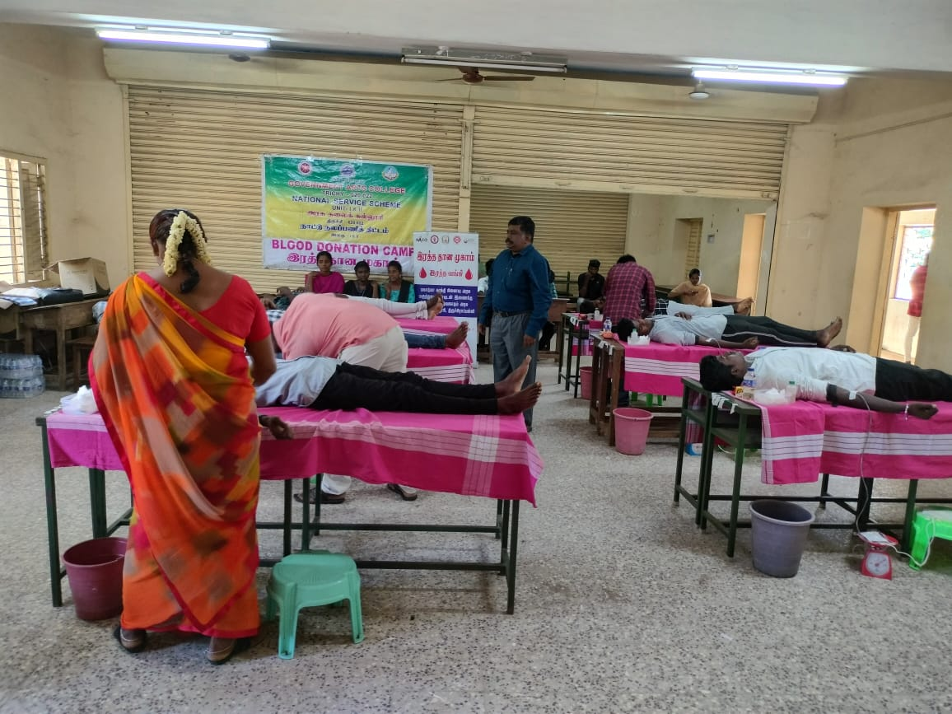

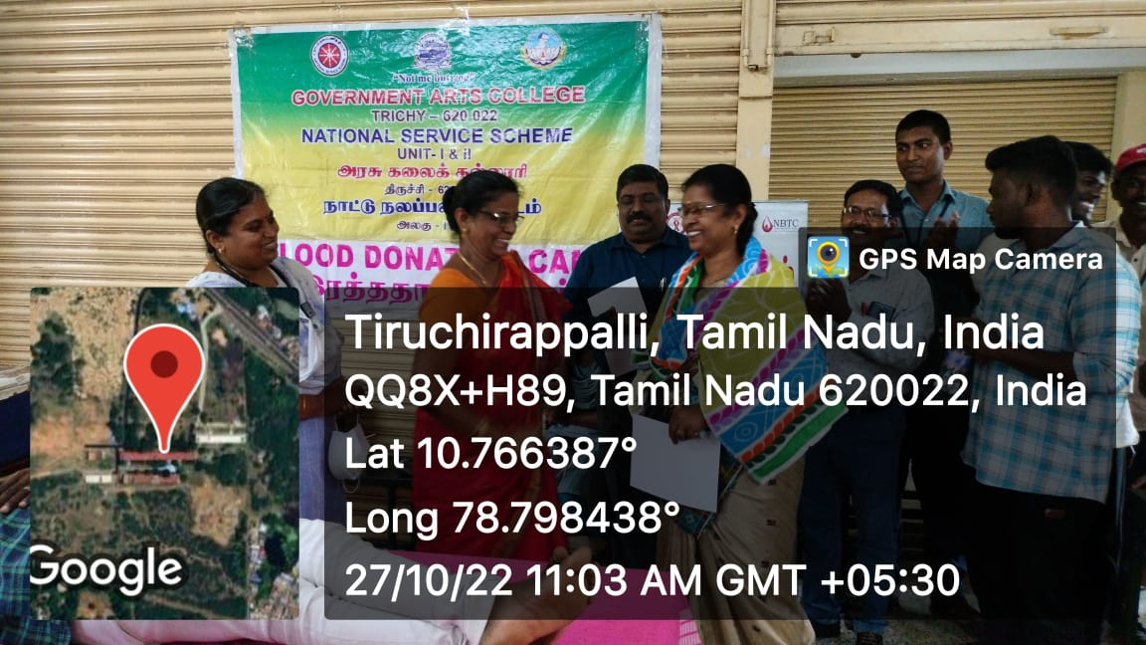
NAME OF THE PROGRAME: Road safety awareness rally
NUMBEROF PARTICIPATIONS: 100
Date:28-10-2022
PROGRAMEOrganizer:Dr.J.THOMASJOSEPHPRAKASH,PO-UNIT-II
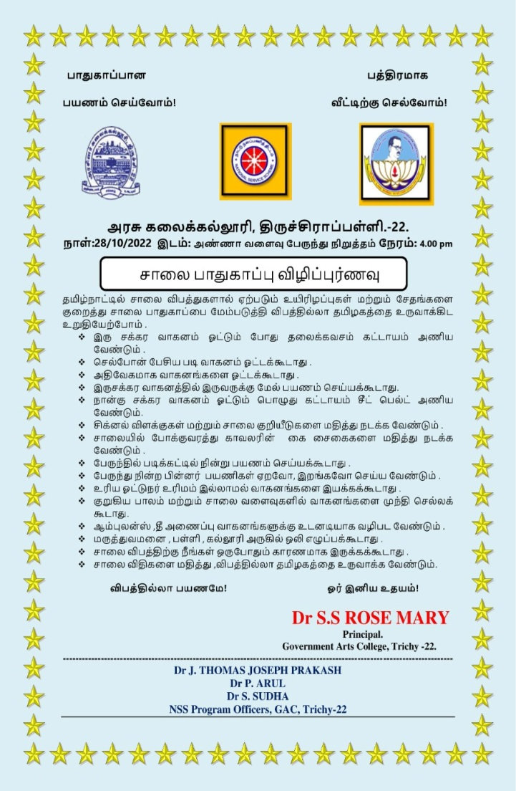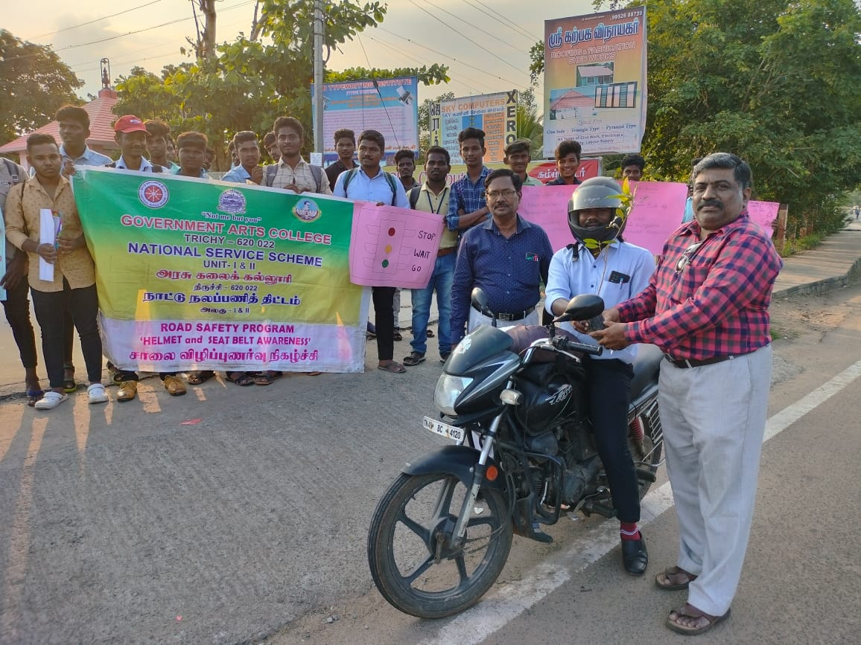

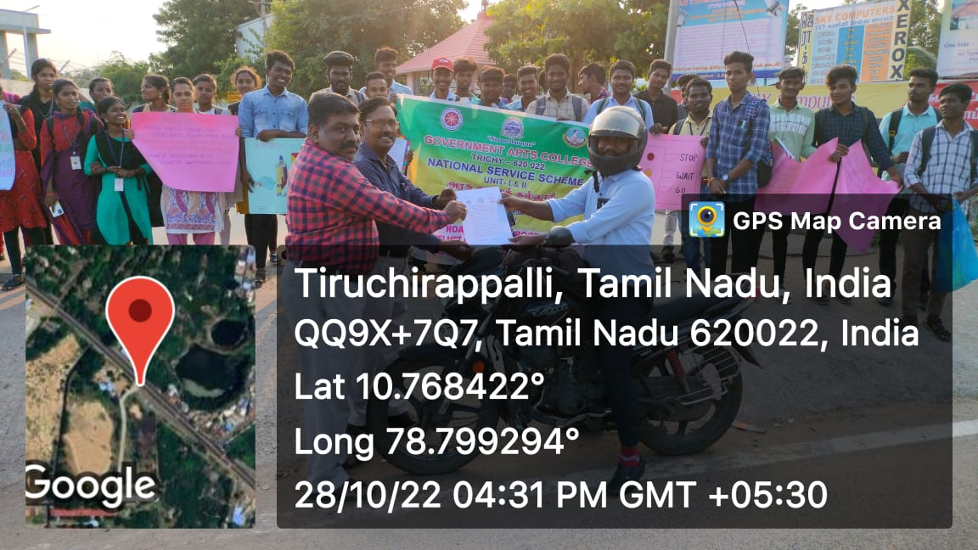
NAME OF THE PROGRAME: national integrity day
NUMBEROF PARTICIPATIONS: 100
Date:31-10-2022
PROGRAMEOrganizer:Dr.J.THOMASJOSEPHPRAKASH,PO-UNIT-II
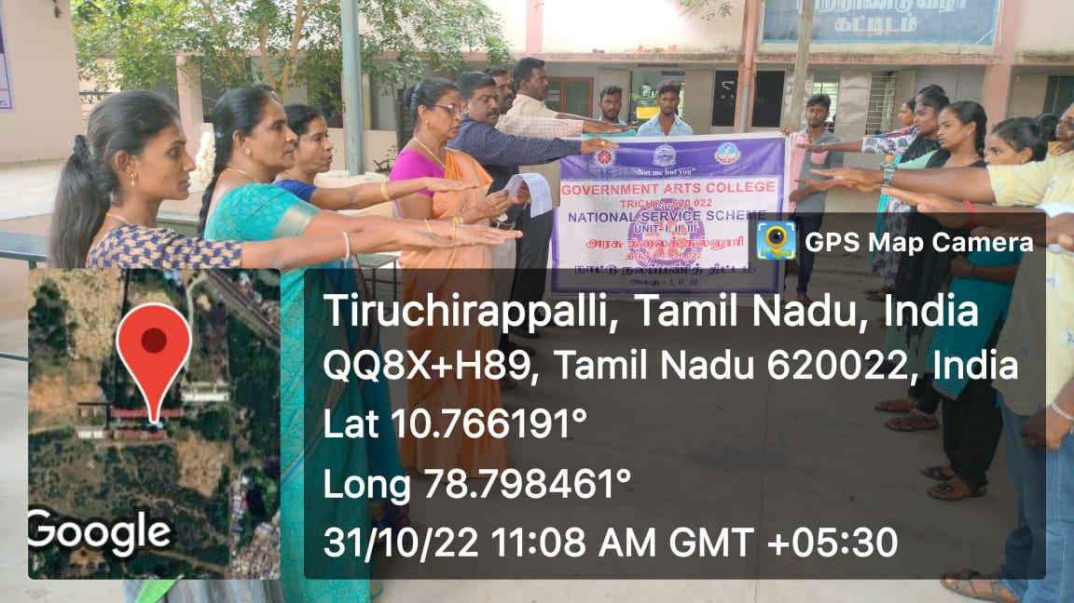

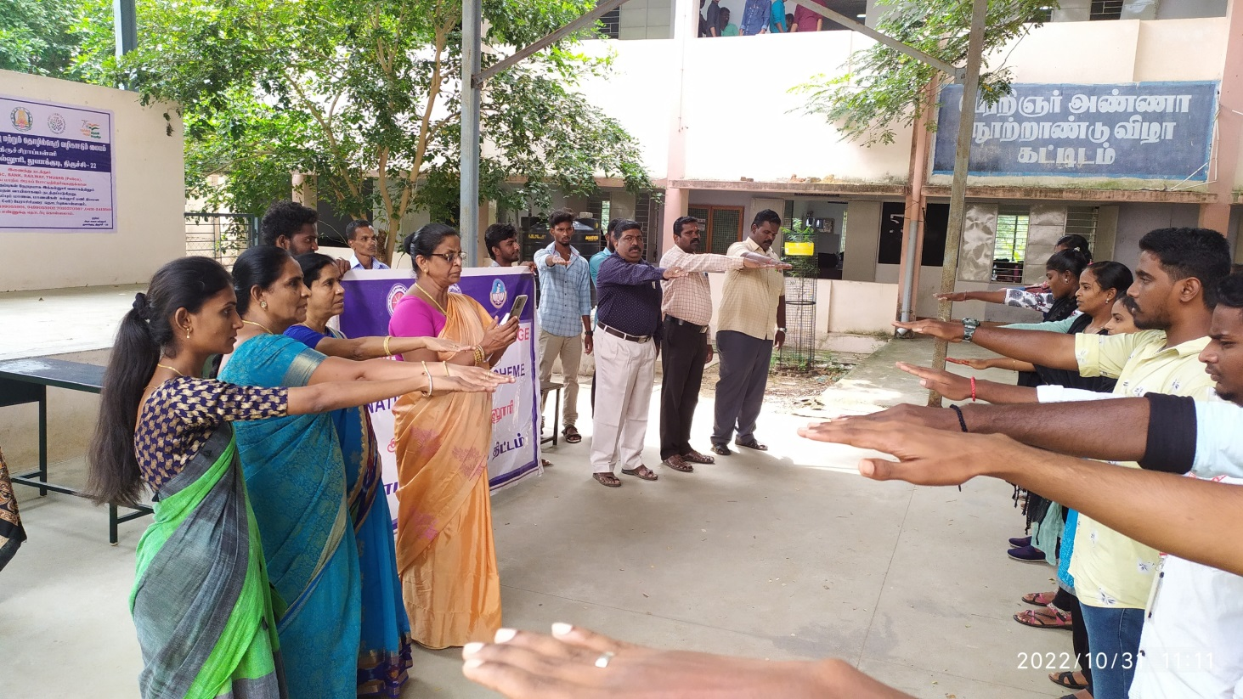

NAME OF THE PROGRAME: free medical check up camp for sugay and BP
NUMBEROF PARTICIPATIONS: 50
Date:31-10-2022
PROGRAMEOrganizer:Dr.J.THOMASJOSEPHPRAKASH,PO-UNIT-II
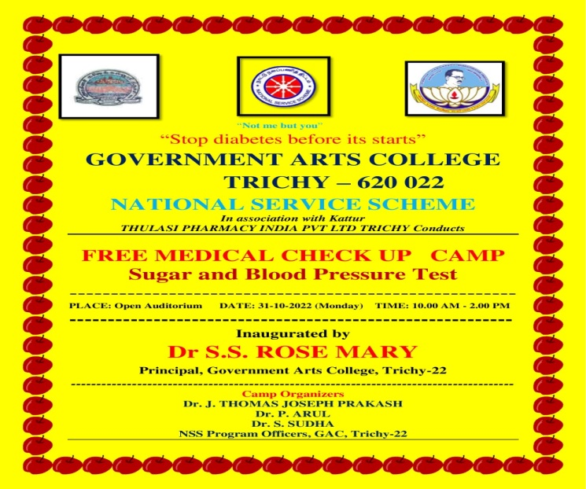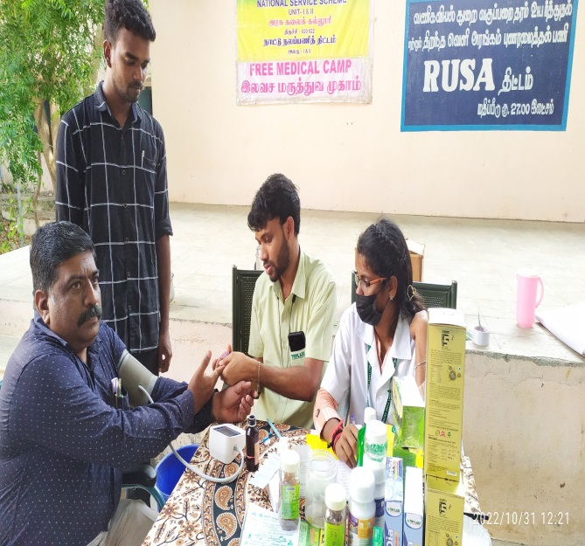

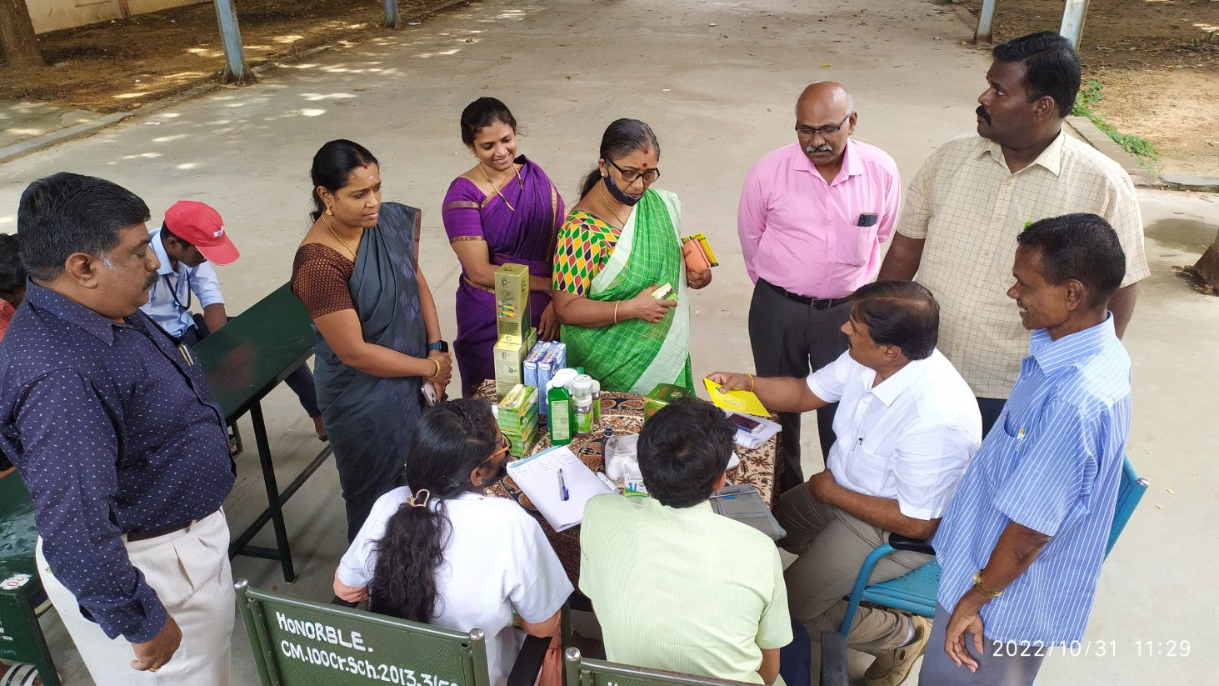

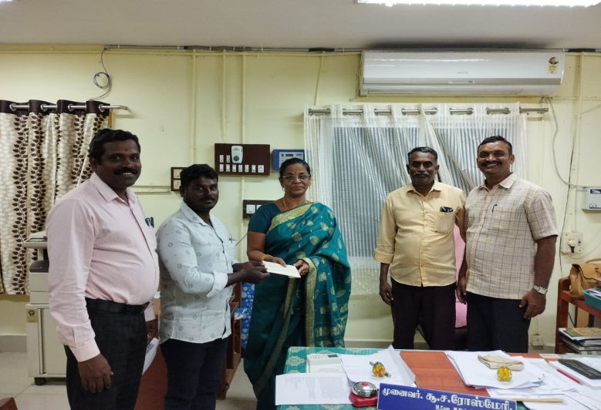
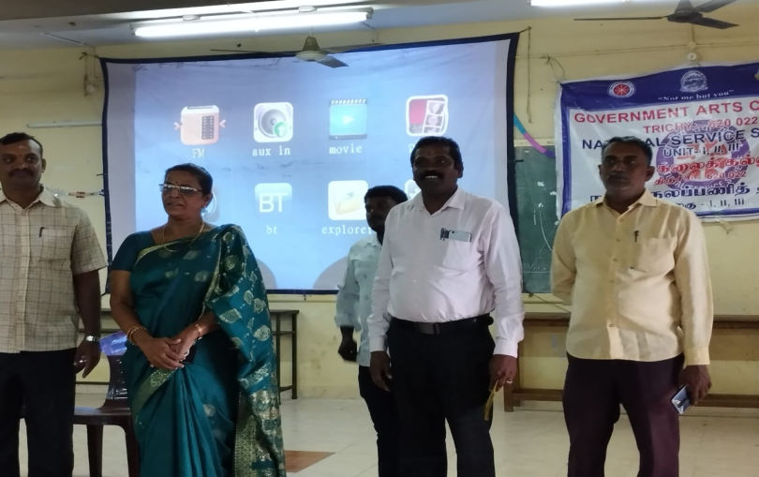
“VetriNichayam” movie

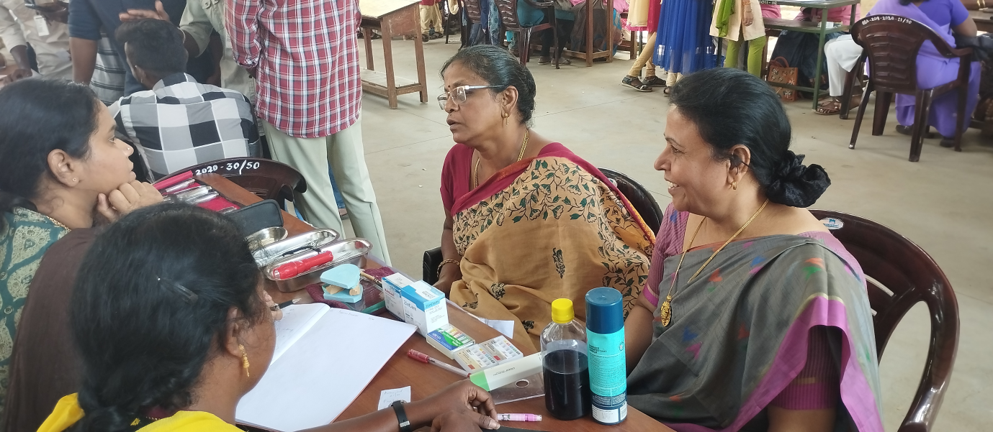
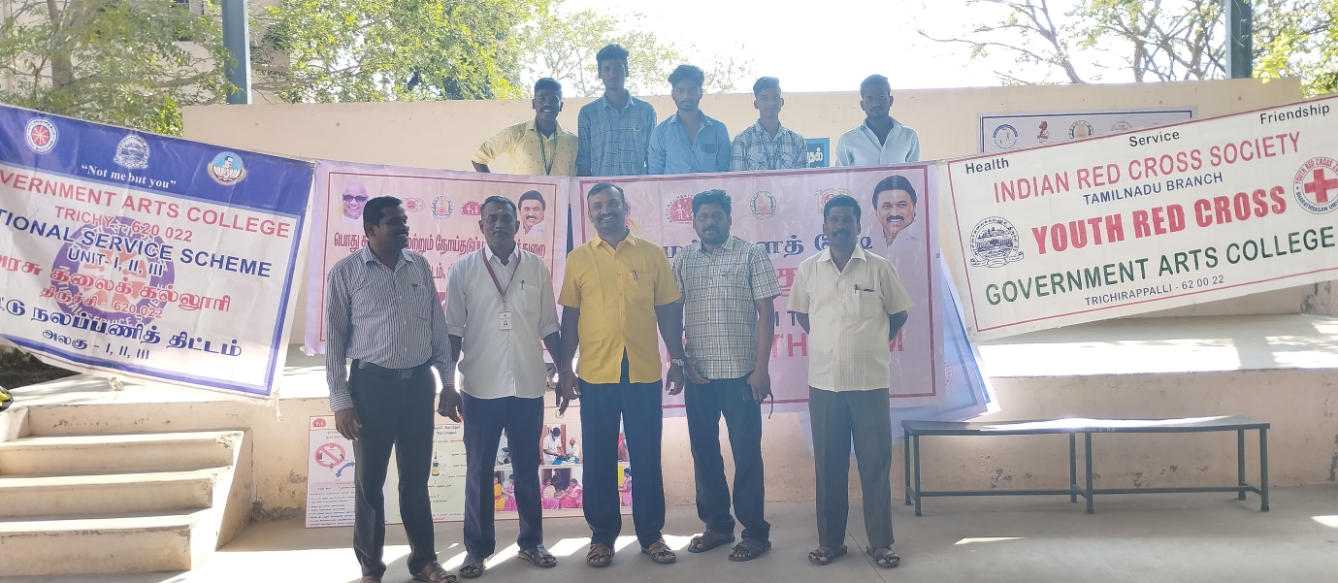

HEALTH MELA

