Learning Resource Centre
Government Arts College
Tiruchirappalli - 22

Mission: Enrich Teaching and Learning by Providing the highest quality of Information to all its users
Vision : Discovering Knowledge through wisdom with adequate Resources

The Library envisions that it will fulfill its unique role as a major contributor to the academic, cultural, and social development of the college community. Modern Library should support research and learning community by discover, preserve and disseminate knowledge through Physical and Digital content this is what exactly GAC Library is doing.
GAC Library started in the year 1973.now it is a computerized Library with Barcode facility. Library ID no provided to the students in the College ID itself with Barcode Technology. The carpet area of the library is 1917 sq. ft. including a reading hall of 1164 sq. ft. A stockroom of 648 sq.ft., e-resource centre 105 Sq.ft.
Library Hours : Book Issue : 10.00am - 4.00Pm
LIBRARY SOFTWARE : NIRMAL SUITE 2014 Library Software.
LIBRARY COLLECTION :
At present there visiting members of the library are 15000. There are 31500 books, 40,000 e- Journals, 2100 reference books, 145CDs, and N-list are available in the library.
Library Services:
Multisubject Gateway: Learning Resource Center of Government Arts College,Trichy -22, Open a library website during the COVID-19 namely Multisubject Gateway 2020, provides learning materials through online from August 2020 to till date. This is a small step to provide E-Resources to assist Students and Teachers in their learning process. Odd Semester Unit wise materials provided for 19 Departments 24 Subjects 184 Papers including 7 Science Departments and 12 Arts Departments. Resources compiled and link circulated to students. Library website User & Mobile friendly, user can download the learning resources anywhere any time at free of cost. As per Google Analytics 442 users viewed 3088 page views proves that this website have a very good response among users.
https://sites.google.com/view/mutisubjectgateway2020/home?authuser=0
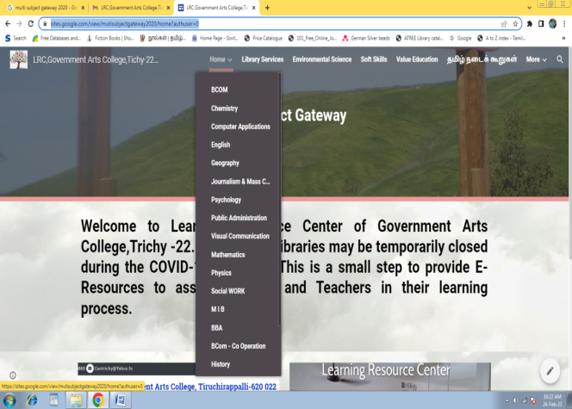

4.Mathgateway07: . Mathgateway07 has a collection of high quality Internet resources in exclusively for Mathematics ,with more than thousand Mathematical websites especially for Mathematic students. Developed and Maintained by the librarian, Government Arts College,Trichy - 22. www.mathgateway07.bravehost.com/
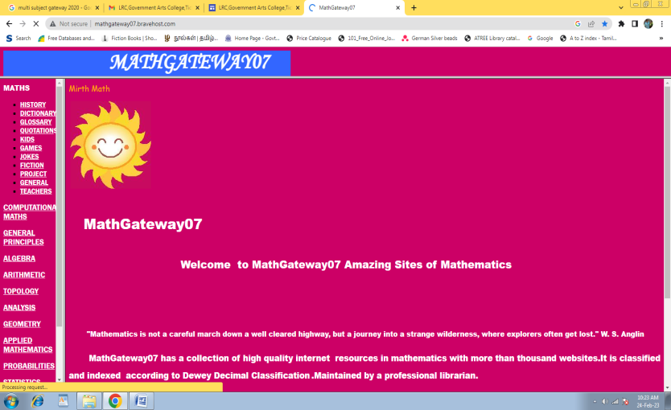
OTHER SERVICES
Internet Access
News Paper Clipping Service
Reprography Services
Referral Services
CAS – Current Awareness Service
SDI – Selective Dissemination of Information Service
Reference and Loan Services
E-Journals
INFLIBNET Nlist : 6237 http://nlist.inflibnet.ac.in/
DOAJ : 12074 https://doaj.org/
Gateways : http://www.mathgateway07.bravehost.com/

Conferences Seminars Organised By Library
1.National Level : Dr.R.Poonkothai, Organising Secretary & College Librarian has organized and successfully completed “National Level webinar on “ Digital Repositories: New Navigation Tools for Online Education” by Google Meet. Ms.E.kajalakshmi,Asst Library Information Officer, National Library of India, Kolkata and Dr K kumaresan, Librraian, Muthurangam Government Arts College,Vellore are Resource Persons for the Webinar held on 22-06-2021 (Tuesday)at 11.00 am.
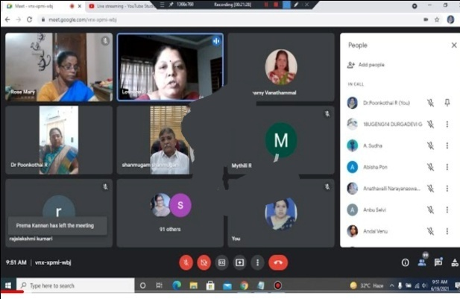
- State Level : Dr.R.Poonkothai, Organising Secretary & College Librarian has organized and successfully completed.“State Level webinar on Sexual Harassment of women at workplace- Prevention, Prohibition, Redressal” by Google Meet. Dr Lovelina Little Flower, Professor & Head Department of Social Work,Dean I/C College Development Council,Bharathiar University ,Coimbatore and Dr R Shanmugam,Advocate,Shanmugam Associates,Coimbatore are Resource Persons for the Webinar held on 19-06-2021 (Saturday)at 09.30 am.
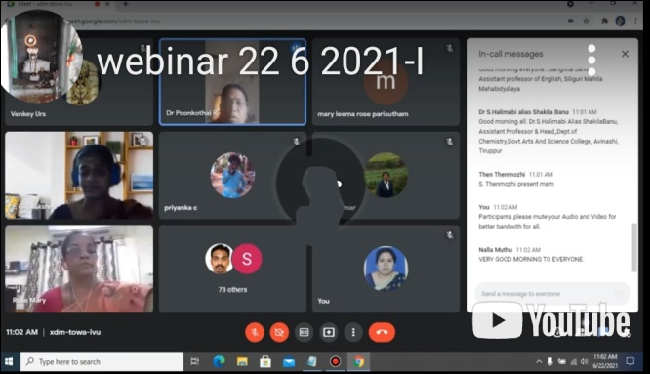
- Our students and staff visited Trichy book exhibition October 2022 part of this our college conducted programme on topic*Vasipom Neasipom* speaker Dr Valarmathi from Tamil department.
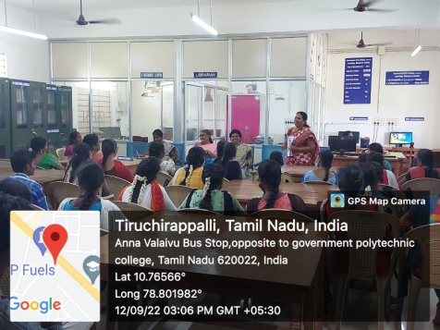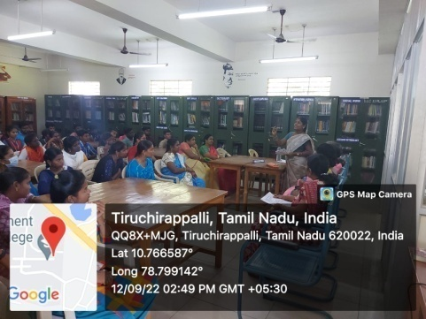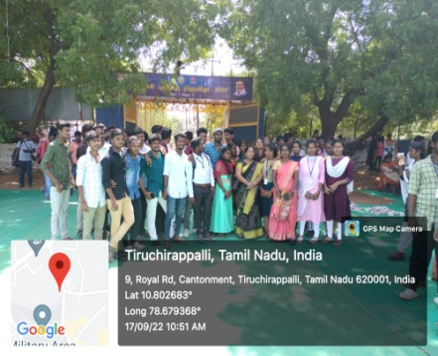
4. Webinar on E Learning Programme
4. Various Online Quiz Programmes Conducted by the library

Internship Programme: “Internship Training”. Given to S.V.Meenatchi, II year Master of Commerce student of Holy cross College (Autonomous), Trichy – 02 She has undergone Library Management Training for Thirty hours (From 19.2.2021 to 03.03.2021).

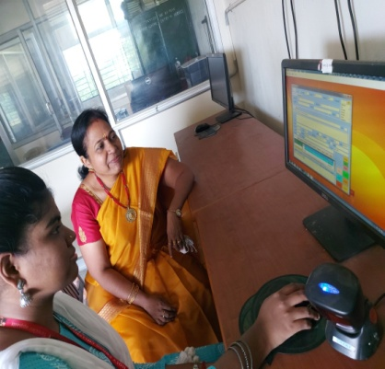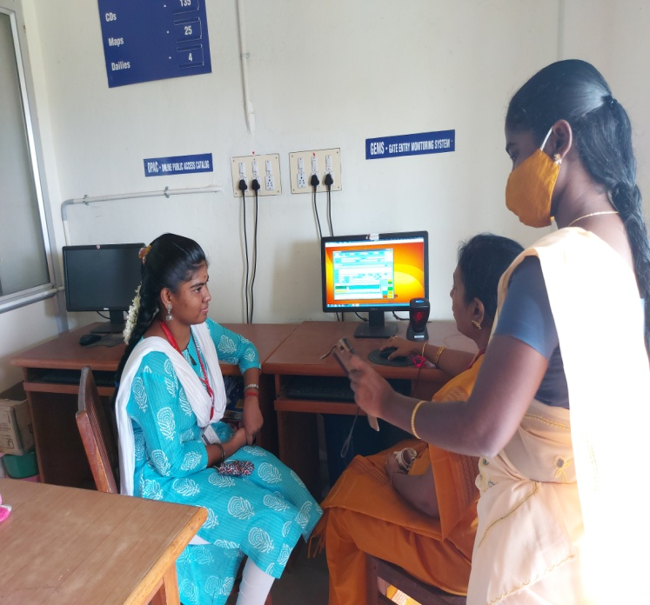
“Internship Training”. Given to MLib.I.Sc Students 20/9/2021 to 25/09/2021 Holy cross College (Autonomous), Trichy – 02

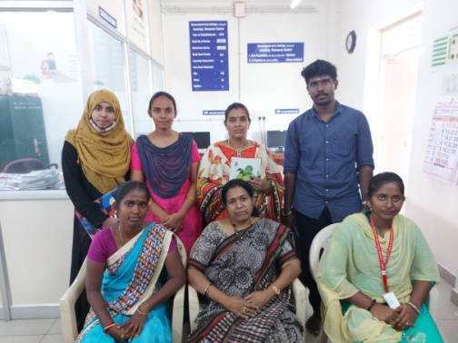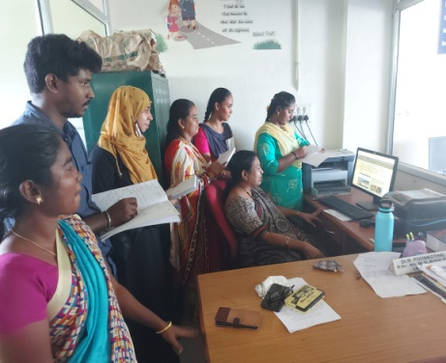

Training Programme for faclty of other colleges

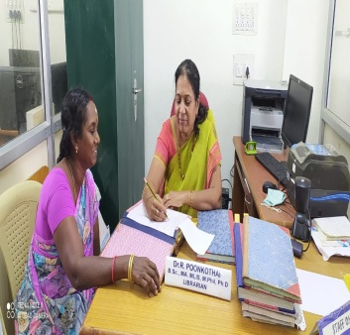 Dr.R .Poonkothai,Librarian,Government Arts College,Trichy 22 Given One Day Training Programme to Dr.N.Rukumani Devi,Librarian,Government Arts And Science College,Kumulur,Lalgudi 621712,Trichy on 01/12/2020 Library Management,Technical work, Acquisition Circulation,Library Service.
SPECIAL FEATURES
CATALOGUE : OPAC
OPAC allow users to find what's available in the Library and can be searched for Author, Title, Keyword and Subject.
Reading Club: To Cultivate reading habit among the students library started Reading Club especially for the First year students
BOOK EXHIBITIONS
As a part of extension service library conducting Book Exhibitions
2021 October 26th & 27th

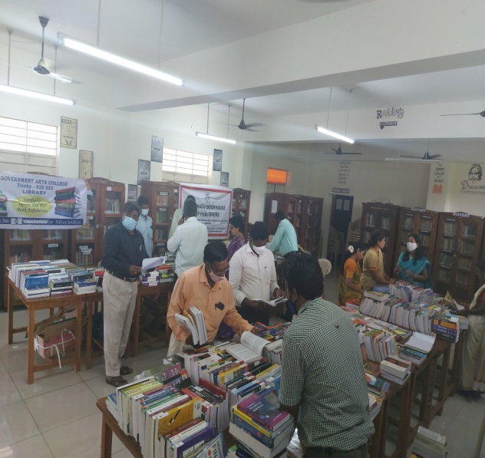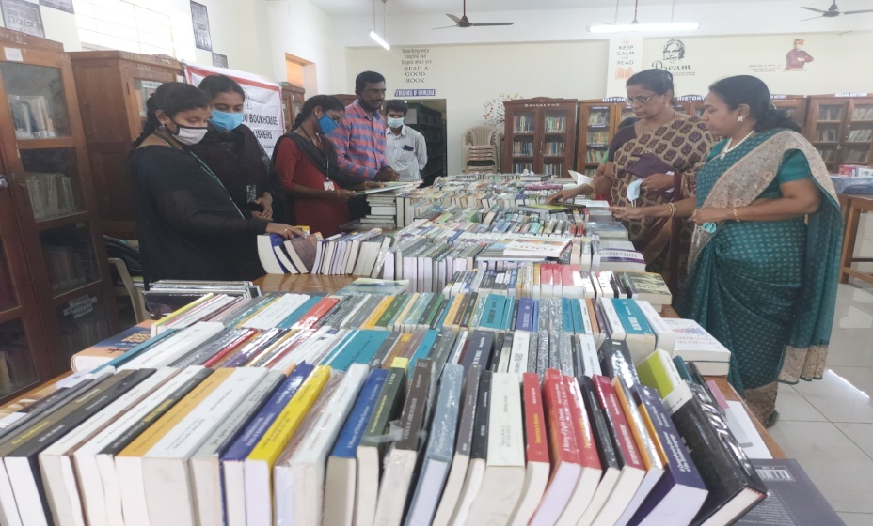

4th March 2022 2023 October 16th & 17th
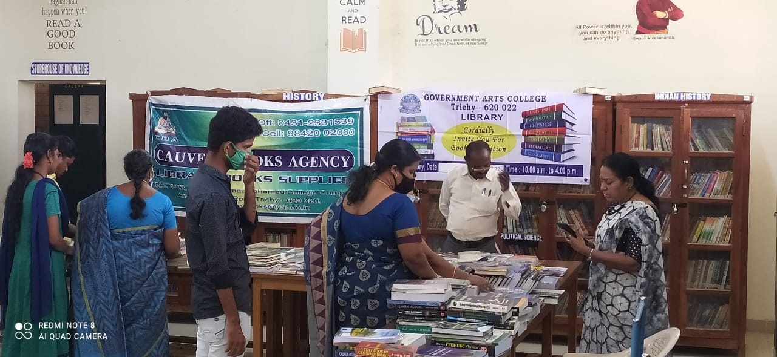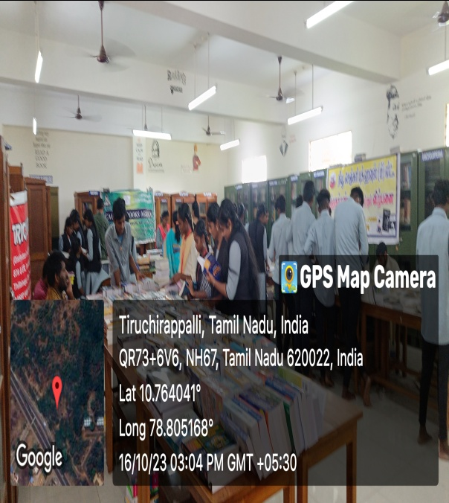

2023-2024
16/10/2023 Book Exhibition
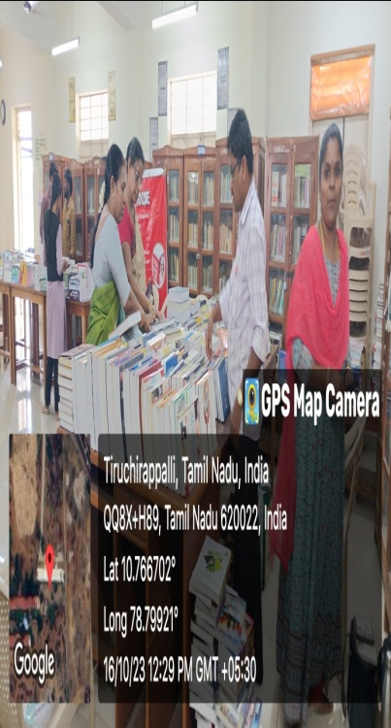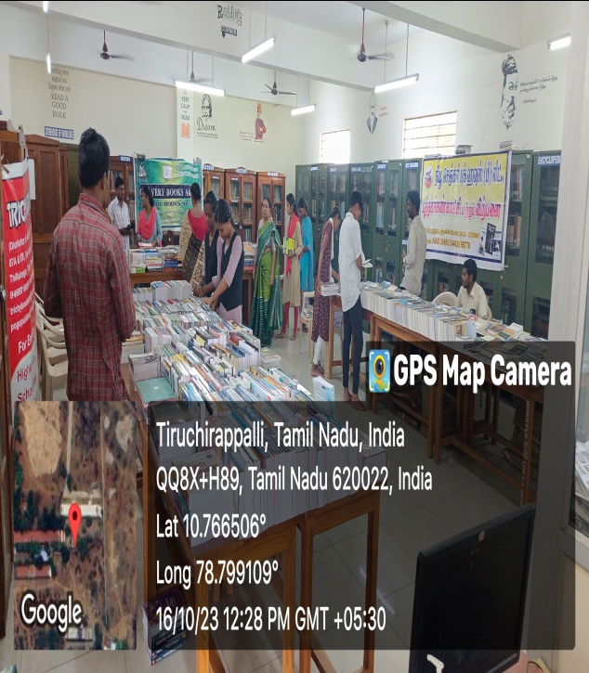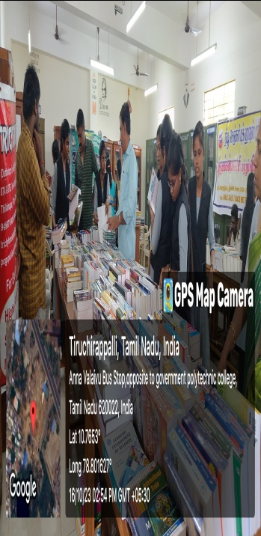

Students of Various Schools Visited Library Under Naan Muthalvan Awareness on Higher Education programme
