INTERNAL QUALITY ASSURANCE CELL

IQAC in the Institution was constituted on 22-09-2009 with a view to initiate, plan and supervise different activities which are important to maintain and improve the quality of education imparted. IQAC is a significant body of the institution which monitors the process of teaching, learning and evaluation. It acts as a powerful recommending body and is actively involved in the quality sustenance of the college. Constitution of IQAC and functioning are based on the guidelines of the University Grants Commission (UGC) and National Assessment and Accreditation Council (NAAC). It conducts periodical meetings with its members and staff for the effective implementation of qualitative initiatives to achieve and sustain excellence in all Academic and Administrative Activities of the College. The IQAC provides support for the various departments and extension clubs in the conduct of academic and extra-curricular seminars, workshops and lectures. Another important and strategically important mission of the IQAC is the consolidation of documents with regard to student and faculty profiles, result analysis, curricular and co-curricular events organised by the college, financial and academic audit, infrastructure development etc.
CONTRIBUTIONS OF IQAC
- Confirms timely, efficient and progressive performance of academic, administrative and financial tasks
- Ensures relevance and quality of academic and research programmes
- Make the academic programmes more affordable and have impartial access by various sections of society
- Optimization and integration of modern methods of teaching and learning
- Confirms the credibility of evaluation procedures.
- Ensuring the suitability, maintenance and functioning of the support structure and services
- Sharing or research work and having networking with other institutions in India and abroad.
- Quality enhancement by focus on institutional functioning though keen focus and clarity.
- Internalization of the quality culture and institutionalize all good practices by ensuring enhancement and coordination among various activities
- Act as a dynamic system for quality changes in the institution.
- Build an organised methodology of documentation and internal communication.

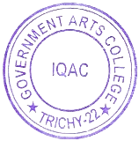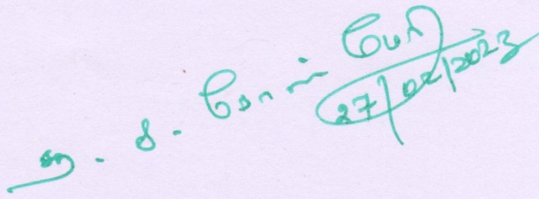

OBJECTIVES OF IQAC
The objective of IQAC is to ensure quality standards in teaching, learning and evaluation patterns and related activities. IQAC administers various new academic activities to supplement the existing practices. Further, it encourages activities in the co-curricular and extra-curricular spheres.
FUNCTIONS OF IQAC
- Developing ethical work culture in the Institute
- Improving the academic and administrative performance of the Institution
- Organizing inter and intra Institutional Conferences, Workshops, Seminars, Project Exhibition and Research Activities
- Playing as a nodal agency of the institute for coordinating various activities ensuring quality and dissemination of best methods and practices
- Ensuring a learner-centric ambience conducive for quality education and for continual improvement
- Emphasizing faculty expertise to adopt the knowledge, technology and innovations for participatory teaching and learning process
- Inviting suggestions and recommendations from students, parents and stakeholders on quality emphasizing institutional policies & processes
- Documentation of all the activities leading to quality improvement
- Collecting and Analysing Feedback from Students, Alumni and Parents

Composition of IQAC for the year 2020-21

Chairperson
Principal

Dr. A. Megala - from 10.09.2019 to 22.09.2020
Dr.S.S.Rose Mary - from 23.09.2020 onwards
Coordinator
Dr. S. Yahya Mohamed
Assistant Professor of Mathematics
Members
Dr.S. Umamatheswari, Assistant Professor of Chemistry
Dr. V. Ramapriya, Assistant Professor of English
Dr. G. Muralidaran, Assistant Professor of Tamil
Dr. J. Prabhakaran, Assistant Professor of Political Science
Dr. T. Akkila, Assistant Professor of Physics
Dr. A. Mumtaj, Assistant Professor of History
Dr. T. Gayathri, Assistant Professor of Computer Science
Dr. L Durga Devi ,Assistant Professor of Electronics
Dr. M. Sugirtha, Associate Professor of Political Science
Administrative Staff
Ms.A Shakila, Bursar
External Experts
Dr.R. JosephPonnaiah, Professor, NIT, Trichy
Prof. S.M.P Thangapandian
Rtd.AssistantProfessor of English
Stake Holder
Mr. Rajappa Rajkumar, Industrialist

Alumni Members
Mr.A. Stalin, Assistant Professor of English,
AV Arts and Science College, Thanjavur.
Mr. Pazhamalai, Guest Lecturer, Department of Cooperation,
Government Arts College, Trichy-22

Student members
Thulasinathan S.K. II MIB
GunaseelyE. II M.Sc. Chemistry
Ranjit Kumar. S. IIM.A.History

HIGHLIGHTS OF INTERNAL QUALITY ASSURANCE CELL
(2021 – 2022)
QUALITY INITIATIVES OF IQAC
➢ IQAC Workshops
➢ State Level Seminars
➢ National Level Seminars
➢ Inter National Level Seminars
➢Webinar
➢ AQAR Submission
➢ IQAC Meetings

Introduction
The main aim of the College this year was Academic Adaptation keeping up with the vision-mission statement of the college and the challenges by offering value based education.
Faculty members were motivated to equip themselves to confidently face the challenge of online teaching in the academic year 2021-2022. Online admissions were done using Tamil Nadu Government Arts and Science College Student Admission(TNGASA) is a complete portal, as per the government recommendations. The academic year odd semester examinations was held on online mode. Even semester examinations was held through regular basis.
The college conduct college day, the annual graduation ceremony or fests were organized.

- STUDENT ENROLMENT DETAILS FOR THE ACADEMIC YEAR 2021-22

Programme name | Programme Code | Sanctioned Strength | Admitted
Business Administration | BB | 60 | 56
B.Sc Chemistry English Medium | CH | 31 | 22
B.Sc Chemistry Tamil Medium | CH | 40 | 34
M.Sc Chemistry | CH | 25 | 25
B.Com Commerce Shift I | CM | 60 | 57
B.Com Commerce Shift II | CM | 50 | 45
M.Com Commerce | CM | 35 | 33
BCA Computer Application | CA | 105 | 105
M.Sc Computer Science | CS | 33 | 33
B.Com Cooperation | CO | 60 | 51
M.Com Cooperative Management | COM | 35 | 12
B.Sc Electronics | EL | 40 | 17
M.Sc Electronics | EL | 25 | 8
B.A English | EN | 52 | 42
M.A English | EN | 35 | 13
B.Sc Geography | GE | 40 | 27
B.A History Tamil Medium | HI | 65 | 65
B.A History English Medium | HI | 44 | 44
M.A History | HI | 33 | 25
B.A. Journalism and Mass Communication | JM | 25 | 19
B.Sc Mathematics | MM | 60 | 23
M.Sc Mathematics | MM | 33 | 33
MSW Master of Social Work | SW | 30 | 20
Master of International Business | IB | 35 | 9
B.Sc. Psychology | SY | 25 | 20
B.Sc. Physics | PH | 40 | 29
M.Sc. Physics | PH | 25 | 24
B.A. Political Science | PS | 60 | 60
M.A. Political Science | PS | 30 | 5
M.A. Public Administration | PA | 40 | 40
B.LIT | TA | 50 | 49
M.A Tamil | TA | 35 | 19
B.Sc.Visual Communication | VC | 38 | 32
M.Sc. Visual Communication | VC | 25 | 10
 |  | 1419 | 1106

- PASS PERCENTAGE OF STUDENTS FOR THE ACADEMIC YEAR 2021-22
Program Code | Program Name | Number of students appeared in the final year examination | Number of students passed in final year examination
BBA | Business Administration | 52 | 40
B.Sc | Chemistry | 49 | 31
M.Sc | Chemistry | 24 | 12
B.Com | Commerce Shift I | 34 | 34
B.Com | Commerce Shift II | 34 | 31
M.Com | Commerce | 18 | 18
BCA | Computer Application | 75 | 52
M.Sc | Computer Science | 10 | 10
CO | Cooperation | 43 | 43
B.Sc | Electronics | 14 | 13
M.Sc | Electronics | 5 | 5
B.A | English | 37 | 26
M.A | English | 18 | 6
B.Sc | Geography | 25 | 24
B.A | History | 77 | 73
M.A | History | 12 | 4
B.Sc | Mathematics | 26 | 21
M.Sc | Mathematics | 25 | 14
MIB | Master of International Business | 7 | 6
B.Sc | Psyclology | 25 | 20
B.Sc | Physics | 30 | 26
M.Sc | Physics | 23 | 22
B.A | Political Science | 37 | 27
M.A | Political Science | 10 | 10
MSW | Social Work | 26 | 7
B.Lit | Tamil | 35 | 34
M.A | Tamil | 2 | 2
B.Sc | Visual Comunication | 26 | 18
M.Sc | Visual Comunication | 8 | 7
 | TOTAL | 807 | 611

- Teachers undergone online/face-to-face Faculty development Programmes (FDP)/Refresher Courses/ Webinars/Workshops etc during the year (2021-22)
S.No. | Name of teacher who attended | Title of the program
1 | Dr.K.Tharini | Online Refresher in Chemistry for Higher Education SWAYAM ARPIT ONLINE COURSE
2 | Dr.B.Ramkumar | Two week Online Faculty Development programme on "PEDAGOGY AND RESEARCH MEHODS" HRDC , AMET
3 | Dr.R.Malarvizhi | Two week Online Faculty Development programme on "PEDAGOGY AND RESEARCH MEHODS" HRDC , AMET.
4 | Dr.B.Ramkumar | One week online Faculty development Programme on" Yoga for well being during Covid period "HRDC ,AMET
5 | Dr.B.Ramkumar | One week online Faculty develop ment Programme on" Life Skills and Wellness During pandemic" AMET
6 | Dr.T Asokan | Online Refresher Course in Chemistry , HRDC, Pondicherry University
7 | Dr.K.Thanigaimani | Online Refresher Course in Chemistry , HRDC, Pondicherry University
8 | Dr.R.Malarvizhi | Faculty development on "Current Technology in Chemistry" Easwari Engineering College Chennai-89
9 | Dr.S.Umamatheswari | Five days virtual FDP on " Instrumentation Techniques and Advanced Materials " ANJA College , Sivakasi-626 124
10 | Dr.R.Malarvizhi | FDP on "Recent Trends in Educational Technology" Odisha University of Agriculture and Technology . Bhubaneshwar.
11 | Dr.S.Umamatheswari | Five days National Level online FDP on Recent Advances in Analytical research Techniques Holy Cross College (Autononomous ) Tiruchirappalli
12 | Dr.B.Senthil Sivakumar | Five days National Level online FDP on "Recent Advances in Analytical research Techniques" Holy Cross College (Autononomous ) Tiruchirappalli
13 | Dr.B.Ramkumar | Online Refresher Course in Environmental studies.UGC HRDC SriVenkateswara University Tirupati
14 | Dr.R.Malarvizhi | online Refresher Course in Environmental studies.UGC HRDC SriVenkateswara University Tirupati
15 | Dr.K.Lakshmi Prabha | Online Two week Refresher Course in "Chemical Sciences". TLC Ramanujam College. University of Delhi.
16 | Dr.P.Sahaya Amutha | Online Two week Refresher Course in "Chemical Sciences". TLC Ramanujam College. University of Delhi.
17 | Dr.B.Senthil Sivakumar | Online Two week Refresher Course in "Chemical Sciences". TLC Ramanujam College. University of Delhi.
18 | Dr.A.Kalpana | Online Two week Refresher Course in "Chemical Sciences". TLC Ramanujam College. University of Delhi.
19 | Dr.S.Umamatheswari | Refresher course in " Environmental sciences "UGC HRDC, Madras University
20 | DR. C.Surendra Dilip | One Week International Workshop on Applications of Nanoscience in Multidisciplinary Fields Periyar maniammai Institute of Science and Technology Vallam Thanjavur
21 | DR. R.Sudhakaran | One Week International Workshop on "Applications of Nanoscience in Multidisciplinary Fields" Periyar maniammai Institute of Science and Technology Vallam Thanjavur
22 | Dr.S.Umamatheswari | One Week International Workshop on "Applications of Nanoscience in Multidisciplinary Fields" Periyar Maniammai Institute of Science and Technology Vallam Thanjavur
23 | Dr.K.Lakshmi Prabha | Two days In service trainning Programme in Physical Sciences.TNSCHE Chennai-600 005
24 | Dr.P.Sahaya Amutha | Two days In service trainning Programme in Physical Sciences.TNSCHE Chennai-600 005
25 | Dr.B.Senthil Sivakumar | Two days In service trainning Programme in Physical Sciences.TNSCHE Chennai-600 005
26 | DR. C.Surendra Dilip | Two days In service trainning Programme in Physical Sciences.TNSCHE Chennai-600 005
27 | Dr.A.Kalpana | Two days In service trainning Programme in Physical Sciences.TNSCHE Chennai-600 005
28 | Dr.K.Thanigaimani | Two days In service trainning Programme in Physical Sciences.TNSCHE Chennai-600 005
29 | Dr.S.Umamatheswari | Six days Faculty Development Program on "Green Chemistry for Sustainable Development" SRM institute of Science and Technology Ramapuram Chennai
30 | DR. C.Surendra Dilip | National One week FDP on " ICT tools for Effective Teaching Learning" Kamala Nehru mahavidyalaya , Nagpur
31 | DR. R.Sudhakaran | National One week FDP on " ICT tools for Effective Teaching Learning" Kamala Nehru mahavidyalaya ,Nagpur
32 | Dr.K.Thanigaimani | National One week FDP on " ICT tools for Effective Teaching Learning" Kamala Nehru mahavidyalaya ,Nagpur
33 | Dr.S.Umamatheswari | National One week FDP on " ICT tools for Effective Teaching Learning" Kamala Nehru mahavidyalaya ,Nagpur
34 | Dr.K.Tharini | One Week Online national FDP on "Safer and Greener Chemistry Labs "
35 | Dr. G. Rabia Jahani Farzana | Advanced Short Term Course in Creating Virtual Classroom using Google Tools
 |  | Mendley Training Course
 |  | Workshop on E-content Development using Free ICT Tools
36 |  | Inter Disciplinary Online Two Week Refresher Course/Faculty Development Programme on Managing Online Classes & Co-Creating MOOCs 8.0
37 | Dr. Sujatha Jeyaraman | Inter Disciplinary Online Two Week Refresher Course/Faculty Development Programme on Managing Online Classes & Co-Creating MOOCs 8.0
38 | Dr. D. Immanuvel | Inter Disciplinary Online Two Week Refresher Course/Faculty Development Programme on Managing Online Classes & Co-Creating MOOCs 8.0
39 | Dr. G. Saravana Kumar | Inter Disciplinary Online Two Week Refresher Course/Faculty Development Programme on Managing Online Classes & Co-Creating MOOCs 8.0
40 | Dr. Sujatha Jeyaraman | Inter Disciplinary Online Two Week Refresher Course/Faculty Development Programme on Research Methodology
41 | Dr. D. Immanuvel | Inter Disciplinary Online Two Week Refresher Course/Faculty Development Programme on Research Methodology
42 | Dr.V.GOMATHI | Six Days Faculty Development Program on Integrated Learning and NEP 2020
43 | Dr.V.GOMATHI | Faculty Development Programme on “Investor Awareness”
44 | Dr.V.GOMATHI | Five Day Virtual International Faculty Development Program on “Research Article Writing and Publishing”
45 | Dr.V.GOMATHI | One Week National Level FDP on Investor Awareness and Education
46 | Dr.N.SARATHA | One Week National Level FDP on Investor Awareness and Education
47 | Dr. V.SELVARANI | Online Two-Week Interdisciplinary Refresher Course On Advanced Research Methodology
48 | Dr.V.GOMATHI | Online Two-Week Refresher Course In Commerce And Management
49 | Dr.V.GOMATHI | Online Two-Week Interdisciplinary Refresher Course On Advanced Research Methodology
50 | Dr.N.SARATHA | Online Two-Week Refresher Course In Commerce And Management
51 | Dr.N.SARATHA | Online Two-Week Interdisciplinary Refresher Course On Advanced Research Methodology
52 | Dr.I.NARSIS | Online Two-Week Refresher Course In Commerce And Management
53 | Dr.I.NARSIS | Online Two-Week Interdisciplinary Refresher Course On Advanced Research Methodology
54 | Dr.V.JAISANKAR | Online Two-Week Refresher Course In Commerce And Management
55 | Dr.V.JAISANKAR | Online Two-Week Interdisciplinary Refresher Course On Advanced Research Methodology
56 | N.JAISANGAR | online Refresher Course
57 | V.VIDHYA | Mooc by Swayam
58 | V.VIDHYA | Online Short term Course
59 | Dr.S. Yahya Mohamed | Online two-weeks refresher course in Mathematical science
60 | Dr. A. Faritha Asma | Online two-weeks refresher course in Mathematical science
61 | Dr.P.Umamaheswari | Online two-weeks refresher course in Mathematical science
62 | Dr. S. Sendhamizh Selvi | Online Refresher course in Emerging trends in Modern mathematics
63 | Dr. G. Srividhya | Ugc sponsored online refresher course in ICT in education (MD)Theme: Technology enabled teaching,learning and assessment
64 | Dr.S. Yahya Mohamed | Online one week Faculty development programme on “E-Content Development : Concepts and tools”
65 | Dr.S. Yahya Mohamed | One week Faculty development programme on “Psychological skills for effective teaching and learning”
66 | Dr. S. Sendhamizh Selvi | National Faculty development programme onDeveloping E-Content for MOOC through SWAYAM for an effective instructional experience
67 | Dr.S. Yahya Mohamed | NPTL-Online certification
68 | Dr. A. Gnanam | NPTL-Online certification
69 | Dr. G. Srividhya | Two days In service teacher training programme in mathematical sciences
70 | Dr.S. Yahya Mohamed | International conference on the numrical and analytical techniques in differential equations (ICNATDE-2021)(online),Department of mathematics, Pondicherry university
71 | Dr.S. Yahya Mohamed | International virtual workshop on “structural mathematics using graph Theory”SRMIST,Ramapuram, chennai-600089
72 | Dr.S. Yahya Mohamed | International virtual workshop on “ Introduction to mathematical ecology”
73 | Dr.S. Yahya Mohamed | Webinar on mathematical applications in data science,Department of mathematics, and actuarial science,B.S Abdur Rahman crescent institute of science and technology ,vandalur, chennai-48,
74 | T. Gayathri | Blended and Inclusive Strategies in AI & Machine Learning
 |  | Technologies for the new Era
 |  | Managing Online Classes & Co- Creating MOOCs
75 | S.. Kalvikkarasi | Blended and Inclusive Strategies in AI & Machine Learning
 |  | Technologies for the new Era
 |  | Managing Online Classes & Co- Creating MOOCs
76 | Dr.P. Calduwel Newton | Managing Online Classes & Co- Creating MOOCs
77 | Dr.J.Prabhakaran | UGC sponsored Online Refresher Course in Political Science and Public Administration
78 | Dr.A.Angamuthu | Gender Studies- Refresher courses

- CAREER GUIDANCE PROGRAMME:
Internal Quality Assurance Cell in collaboration with Several Companies with the following objectives.
- Registration of job seekers
- Providing career and vocational guidance to the job seekers.
- Providing coaching to competitive examination
- Sensitizing job opportunities in private sectors
- Self-Employment opportunities and skill training program.
Those Companies are highlighted on courses for higher education, Private and Government Employment Opportunities, Competitive examinations, Self Employment opportunities and skill training programme and free coaching classes.

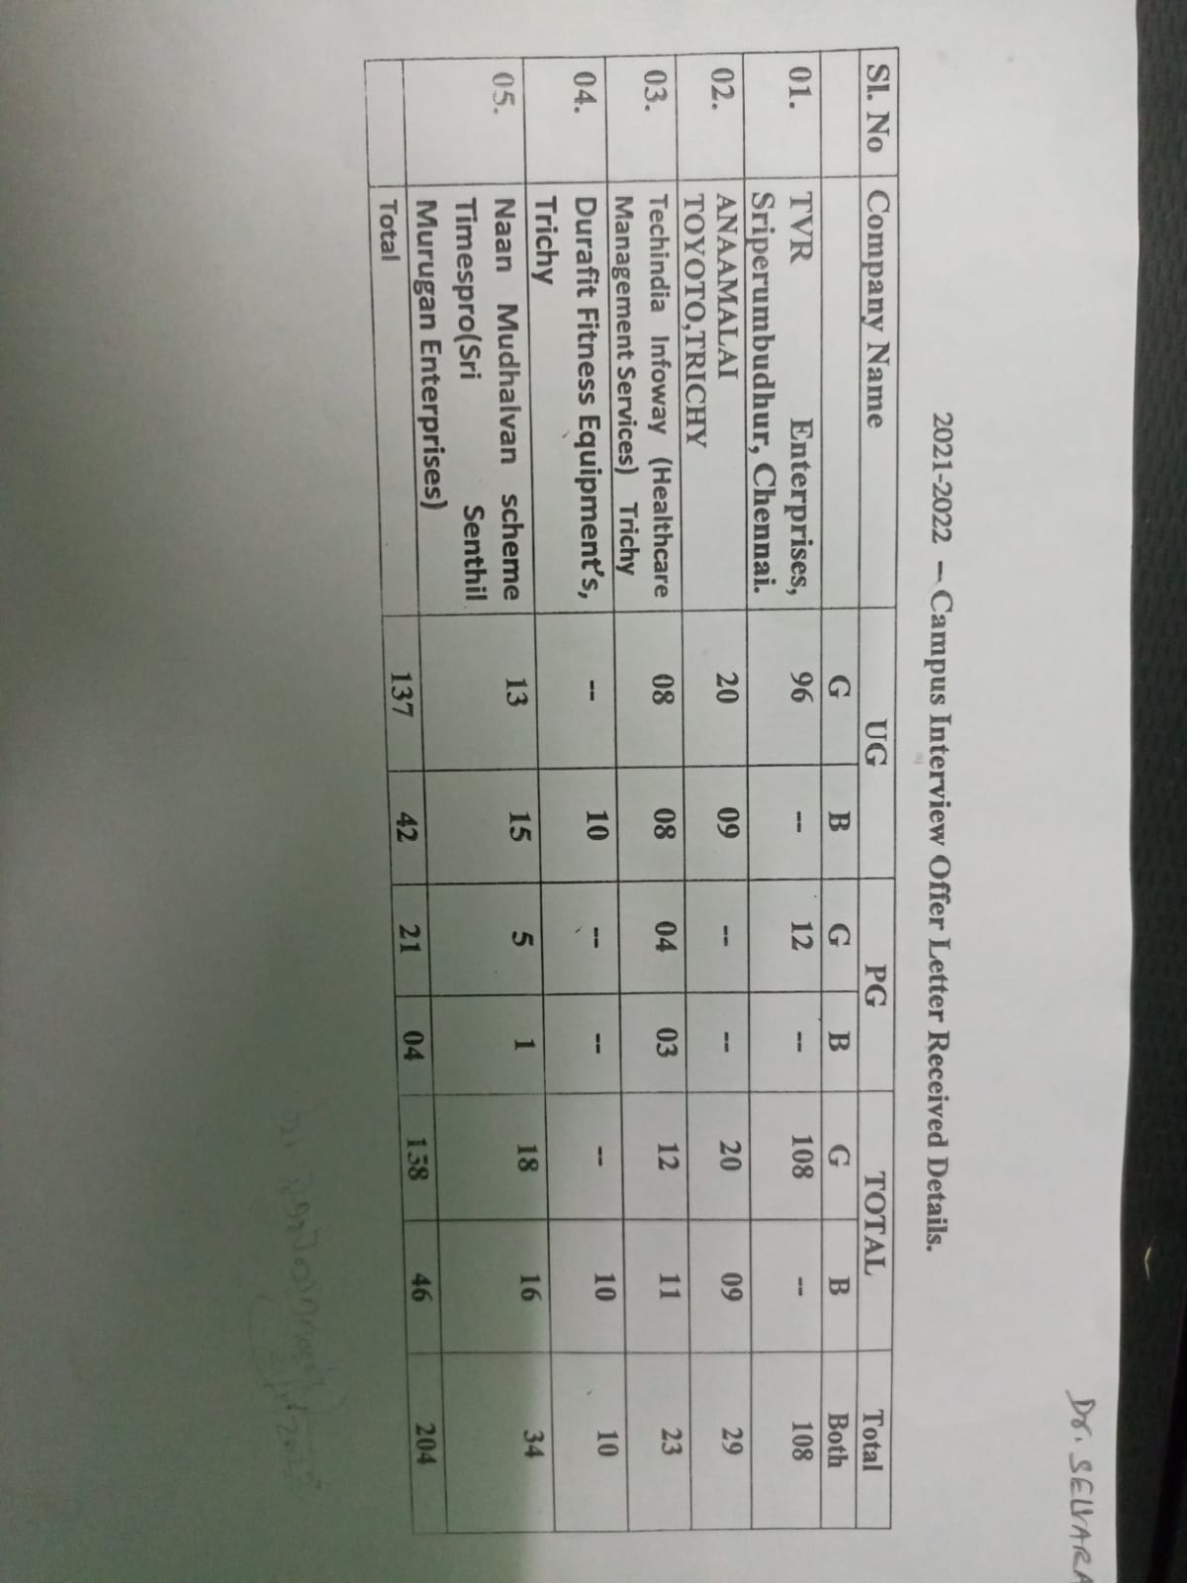

V. CAPABILITY BUILDING: WORKSHOPS/WEBINAR/E-QUIZ ORGANIZED
WORKSHOP:
WORKSHOP Internal quality Assurance cell of Government Arts College, Tiruchirappalli – 22, conducted One Day Workshop on Quality Sustenance in Higher Education Institutions on 8th June 2022. In the workshop Dr. A. Rose Venis, Dean IQAC, Associate Professor of Chemistry, St. Joseph’s College (Autonomous), Tiruchirappalli, delivered a lecture on “Quality Sustenance in Higher Education Institutions”. Dr. S. Yahya Mohamed, IQAC Coordinator, Assistant Professor of Mathematics, Government Arts College, Tiruchirappalli – 22, welcomed the gathering. Dr. S. S. Rose Mary, Principal, Government Arts College, Tiruchirappalli – 22, delivered Presidential address. Dr. S. Umamatheswari, IQAC Member, Assistant Professor of Chemistry, Government Arts College, Tiruchirappalli – 22, delivered vote of thanks. All Head of the departments and faculty members of Government Arts College were actively participated

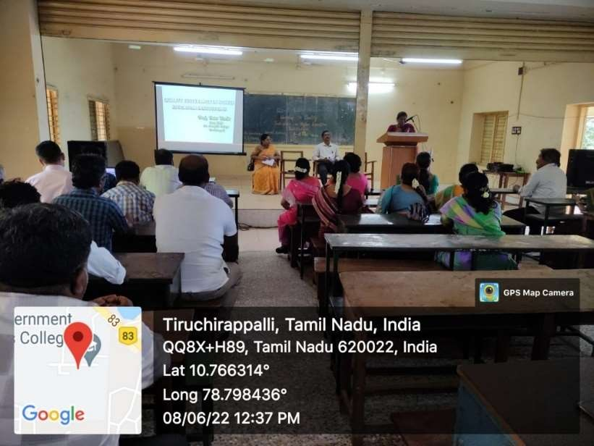
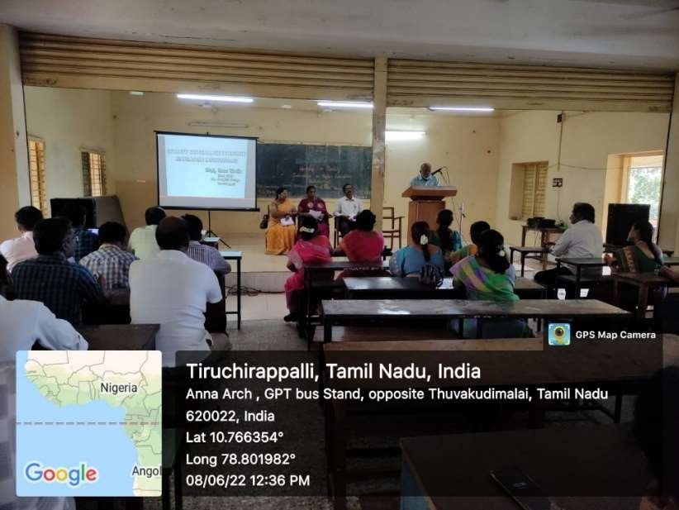
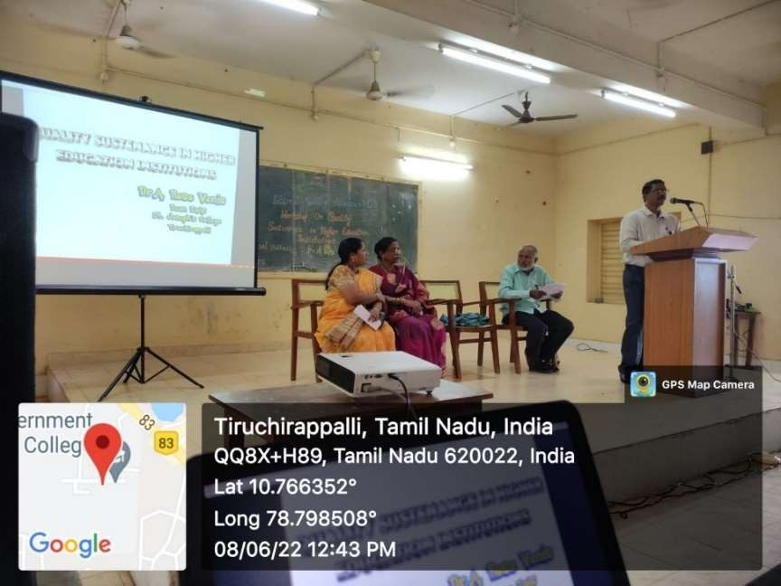
INTERNATIONAL LEVEL SEMINAR:

Internal Quality Assurance Cell (IQAC) and PG & Research department of chemistry, Government Arts College, Tiruchirappalli-22 conducted a One Day International seminar on “EMERGING ADVANCEMENTS IN CHEMISTRY” on 21.04.2022.
In morning session Dr. A. Dennyson Savariraj, Post-Doctoral Research Scientist, Sunchon Nation University, South Korea delivered his address on “Smart Contact lenses for Ocular Theranostics”.
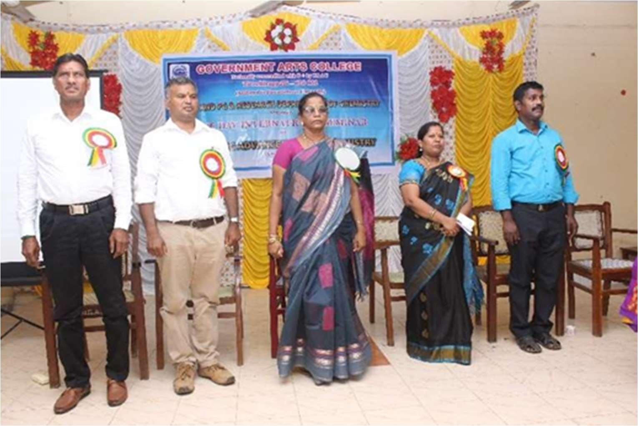
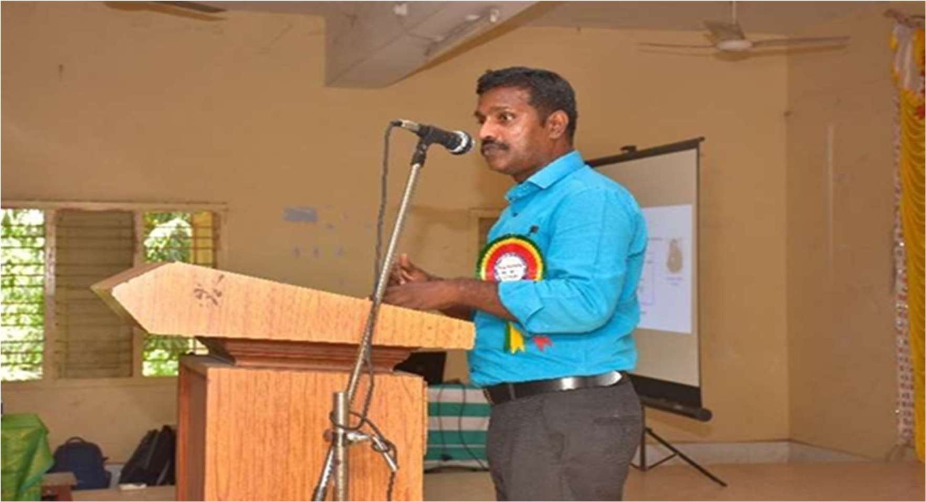
In the afternoon session Dr. J. Elanagovan, Assistant Professor, Department of Chemistry, Raja Serfoji Government College, Thanjavur, Tamilnadu, India spoke on “Serendipities in Chemistry”.

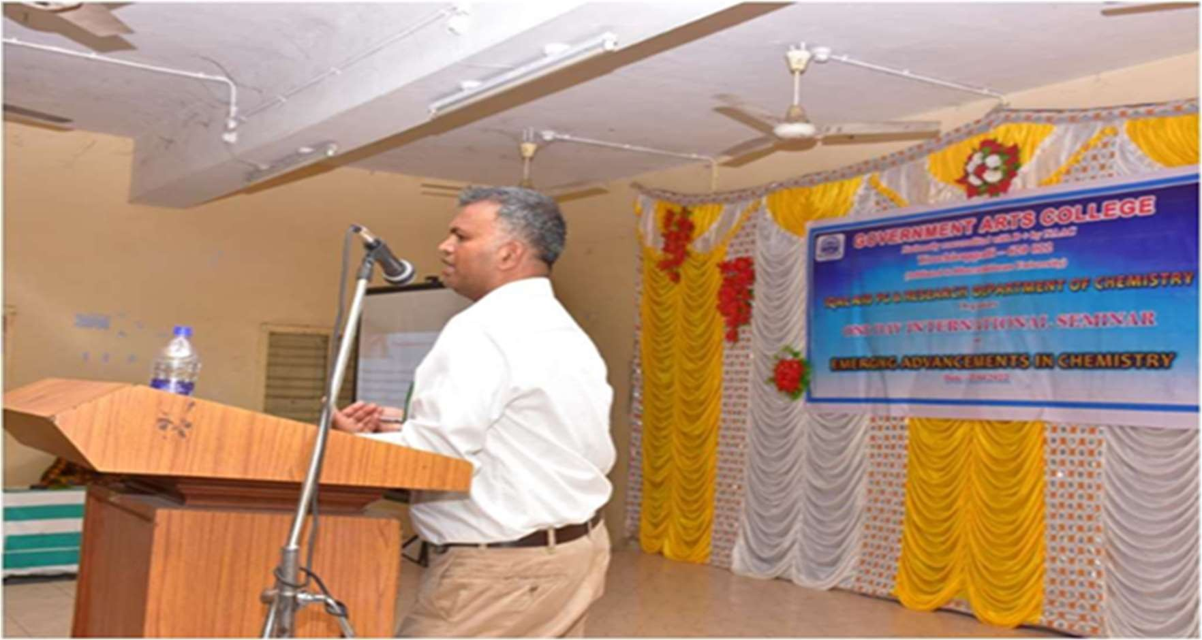

Dr. A. Sivarajan, Assistant Professor and Head of the Department of Chemistry, Government Arts College welcomed the gathering Dr. S. S. Rose Mary, Principal, Government Arts College delivered Presidential Address.
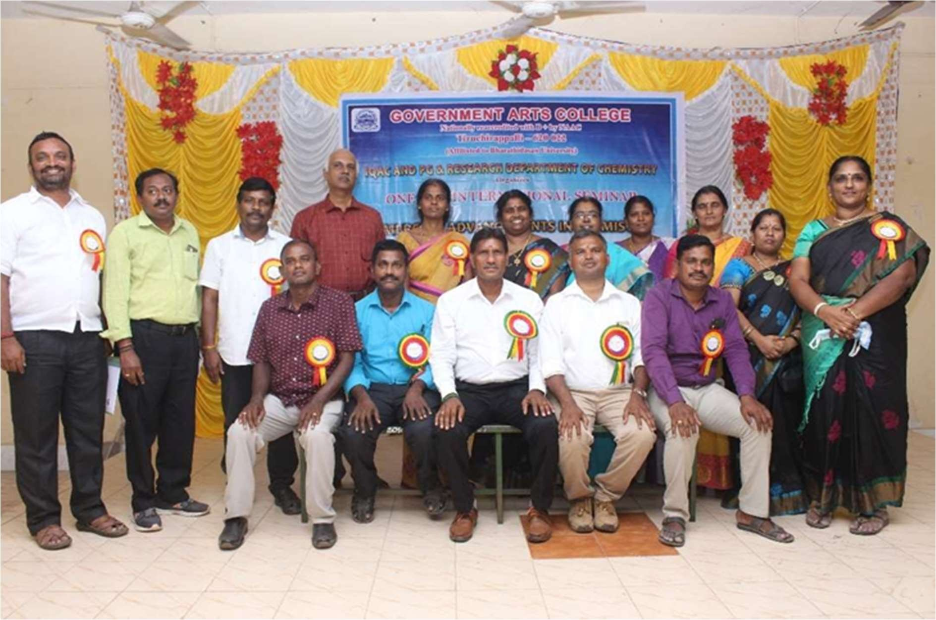
Dr. S. Umamatheswari, Coordinator of the seminar delivered vote of thanks. Dr. P. Sahaya Amutha, Assistant Professor of Chemistry, Co-coordinator of this seminar presented the program.

INTERNATIONAL LEVEL WEBINAR:

- Internal Quality Assurance Cell and PG, Research Department of Chemistry, Government Arts College, Trichy-22, organized one day international level webinar on “CHALLENGES AND OPPORTUNITIES IN ADVANCED MATERIALS” on 14th July 2021. First session was hosted by Dr. J. Balamurugan, Research Assistant Professor, Department of Material Science and Engineering, Korea Advanced Institute of Science and Technology, Republic of Korea and gave a lecture on “Challenges and Opportunities in wearable energy technology”. In the second session, Dr. S. N. Karthik, Assistant Professor, Department of Chemistry, Bharathiyar University, Coimbatore, Tamilnadu, India delivered a lecture on “Fundamental Concepts and Device Fabrication of Super Capacitors”. Being the first graduates of their families, both the resource persons motivated the students for research.
Dr. A. Sivarajan, Assistant Professor and Head of the Department proposed welcome address Dr. S. S. Rosemary, Principal gave presidential address. Dr. P. Sahaya Amutha, Assistant Professor of Chemistry and Organizing Secretary of this webinar introduced both the resource persons Dr. S. Umamatheswari, Assistant Professor of Chemistry and Organizing Secretary delivered vote of thanks. Hundred participants participated through Google Meet platform. More than Hundred participants participated through you tube live streaming.

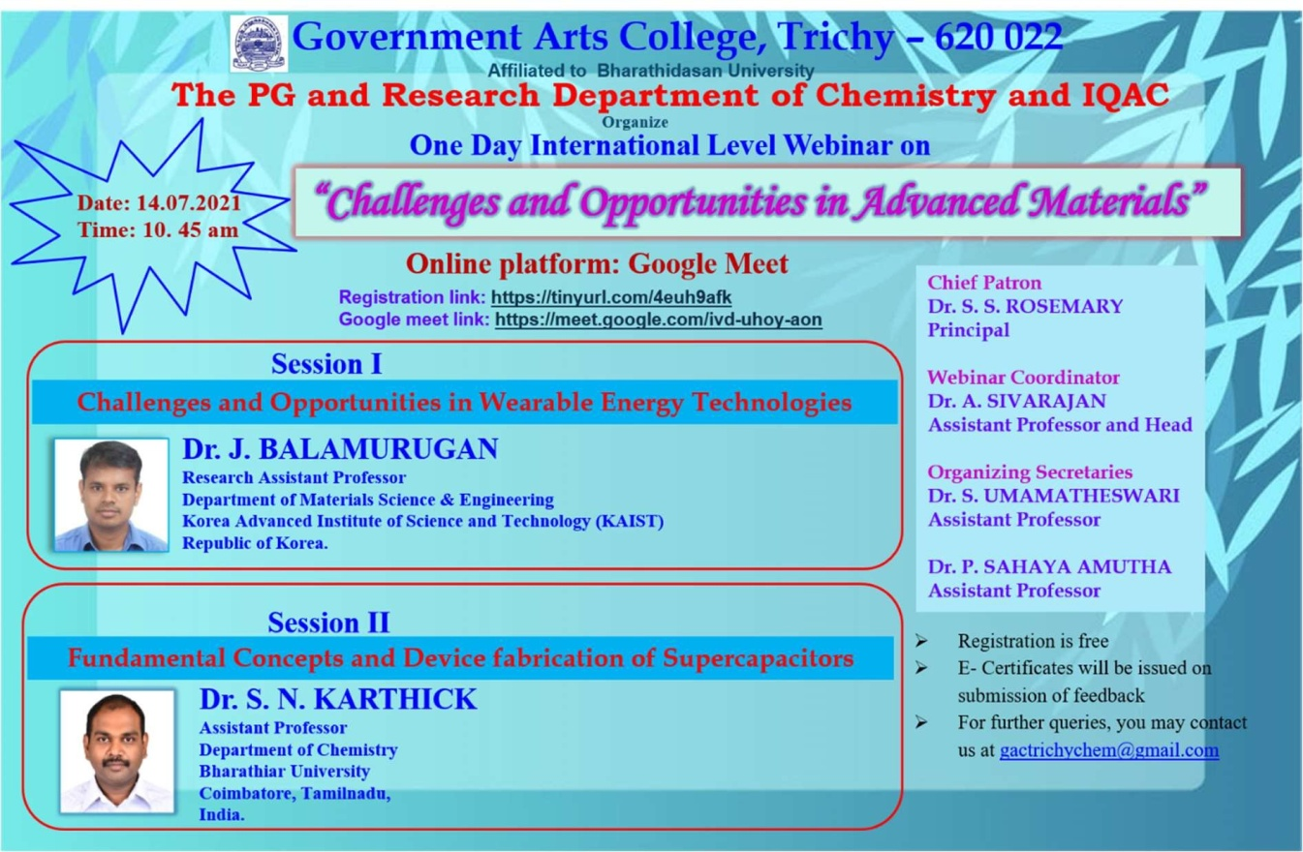

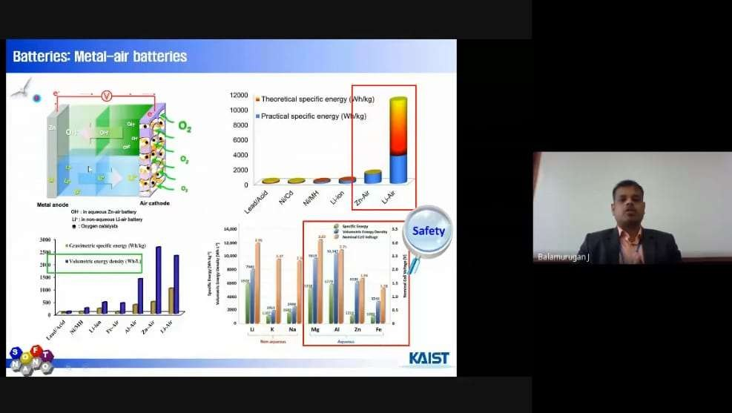

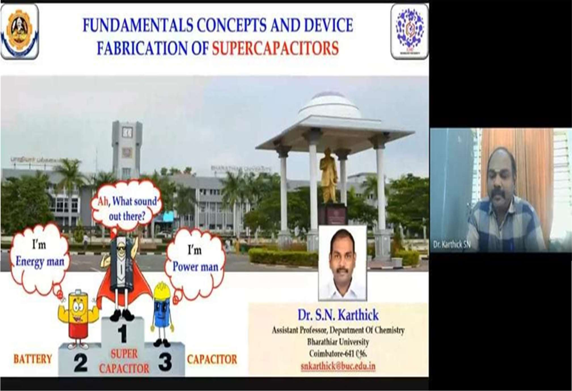

The PG & Research department of chemistry and IQAC Government Arts College, Trichy-22 organized a one day international webinar on “INNOVATIVE RESEARCH IN CHEMICAL SCIENCES (IWIRCS-2021)” on 10.07.2021.

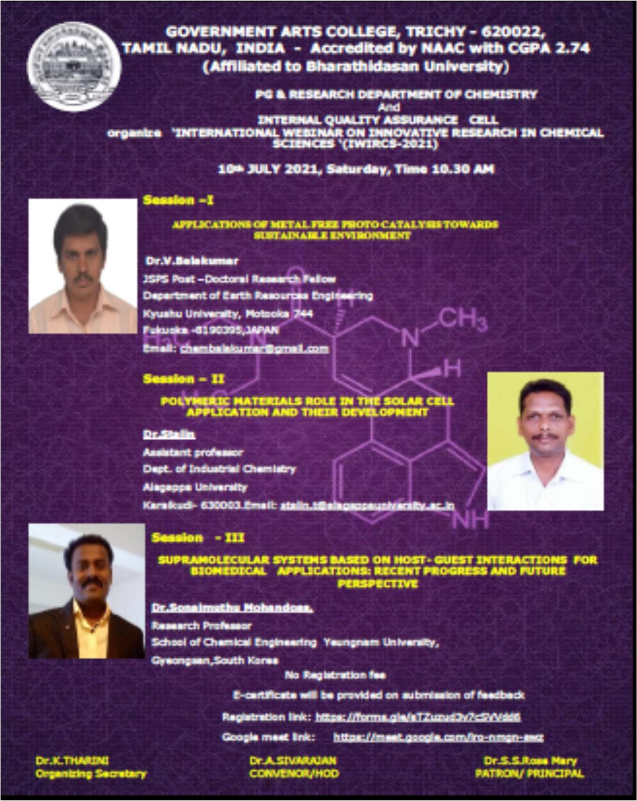

First session was hosted by Dr. V. Balakumar, JSPS Post-Doctoral Research Fellow, Department of Earth Resources Engineering, Kyushu University, Motooka 744, Fukuoka-8190395, Japan and gave a lecture on “Applications of Free Photo Catalysis towards Sustainable Environment” through Google Meet Platform.
In the second session, Dr. Stalin, Assistant Professor, Department of Industrial Chemistry, Alagappa University, karaikudi-63 lecture on “Polymeric Materials Role in the Solar Cell Application and their Development”.

Finally, the third session Dr. Sonaimuthu Mohandass, Research Professor, School of Chemical Engineering, Yeungnam University, Gyeongsan, South korea and gave a lecture on “ Supramolecular Systems Based on Host-Guest Interactions for Biomedical Applications: Recent Progress and Future Perspective”.
The PG & Research department of Mathematics and IQAC Government Arts College, Trichy-22 organized a one-day international webinar entitled “Applications of Mathematics” The webinar started at 11.10 a.m. Dr. S. Sutha, HOD, Department of Mathematics welcomed the gathering, Dr. S. S. Rose Mary, Principal, Government Arts College, Trichy-22 delivered the presidential address and explain some applications of mathematics. Dr. S. Yahya Mohamed, Organizing Secretary of the conference presented the theme of conference and introduced the Chief Guest Prof. Dr. Mridula Kanoria, Professor, University of Calcutta.
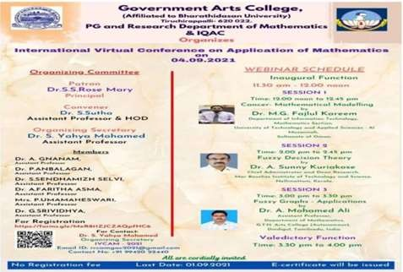
The Resource Person delivered lecture on the topic “Thermal damages of livingtissues due to Hyperthermia Perfusion” and motivated the participants in different research areas. First session was hosted by Dr. M. G. Fajlul Karrem, Department of Information Technology Mathematics Section, University of Technology and Applied Sciences, Al-Musannah, Sultanate of Oman and gave a lecture on Cancer- mathematical modeling.
In Second session Dr. A. Sunny Kuriakose, Chief Administrator and Dean Research,
Mar Baselios Institute of Technology Science, Nellimattam, Kerala, India and gave a
lecture on “Fuzzy Decision Theory”.

In Third Session hosted by Dr. Mohamed Ali, Assistant Professor, Department of Mathematics, G. T. N. Arts College (Autonomous), Dindigul-624 005, Tamilnadu, India and gave a lecture on “Intuitionistic Fuzzy Graph Structures and its Applications”.
The Participants are very enthusiastic for attending this conference. Out of 267 participants, there are 247 from Tamilnadu, 14 from other states of the country and 6 from abroad.

In Third Session hosted by Dr. Mohamed Ali, Assistant Professor, Department of Mathematics, G. T. N. Arts College (Autonomous), Dindigul-624 005, Tamilnadu, India and gave a lecture on “Intuitionistic Fuzzy Graph Structures and its Applications”.
The Participants are very enthusiastic for attending this conference. Out of 267 participants, there are 247 from Tamilnadu, 14 from other states of the country and 6 from abroad.

NATIONAL LEVEL WEBINAR:
Internal Quality Assurance Cell and PG, Research Department of Chemistry, Government Arts College, Trichy-22, Organized one day national level webinar on “Lock down - Positive Perspectives & Challenges ahead” on 2nd July 2021.

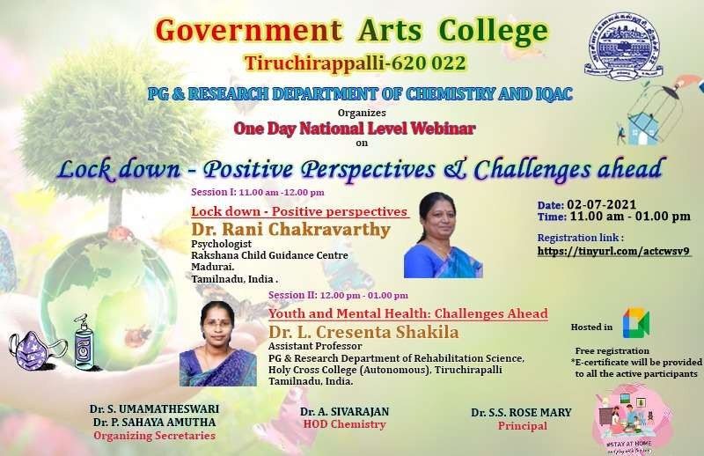

In the first session, Dr. Rani Chakkaravarthy, Psychologist, Rakshana child guidance Centre, Madurai, Tamilnadu delivered a lecture on “Lock down - Positive Perspectives”. The second session was hosted by Dr. L. Cresenta Shakila, Assistant Professor, PG & Research Department of Rehabilitation Science, Holy Cross College, Tiruchirappalli, Tamilnadu and spoke on “Youth and Mental Health: Challenges ahead”.
Dr. A. Sivarajan, Assistant Professor of chemistry and Organizing secretary of the webinar introduced both the resource persons. Dr. P. Sahaya Amutha, Assistant Professor of chemistry and Organizing secretary gave vote of thanks.
Hundred participants participated through Google Meet platform. More than Hundred participants participated through you tube live streaming.

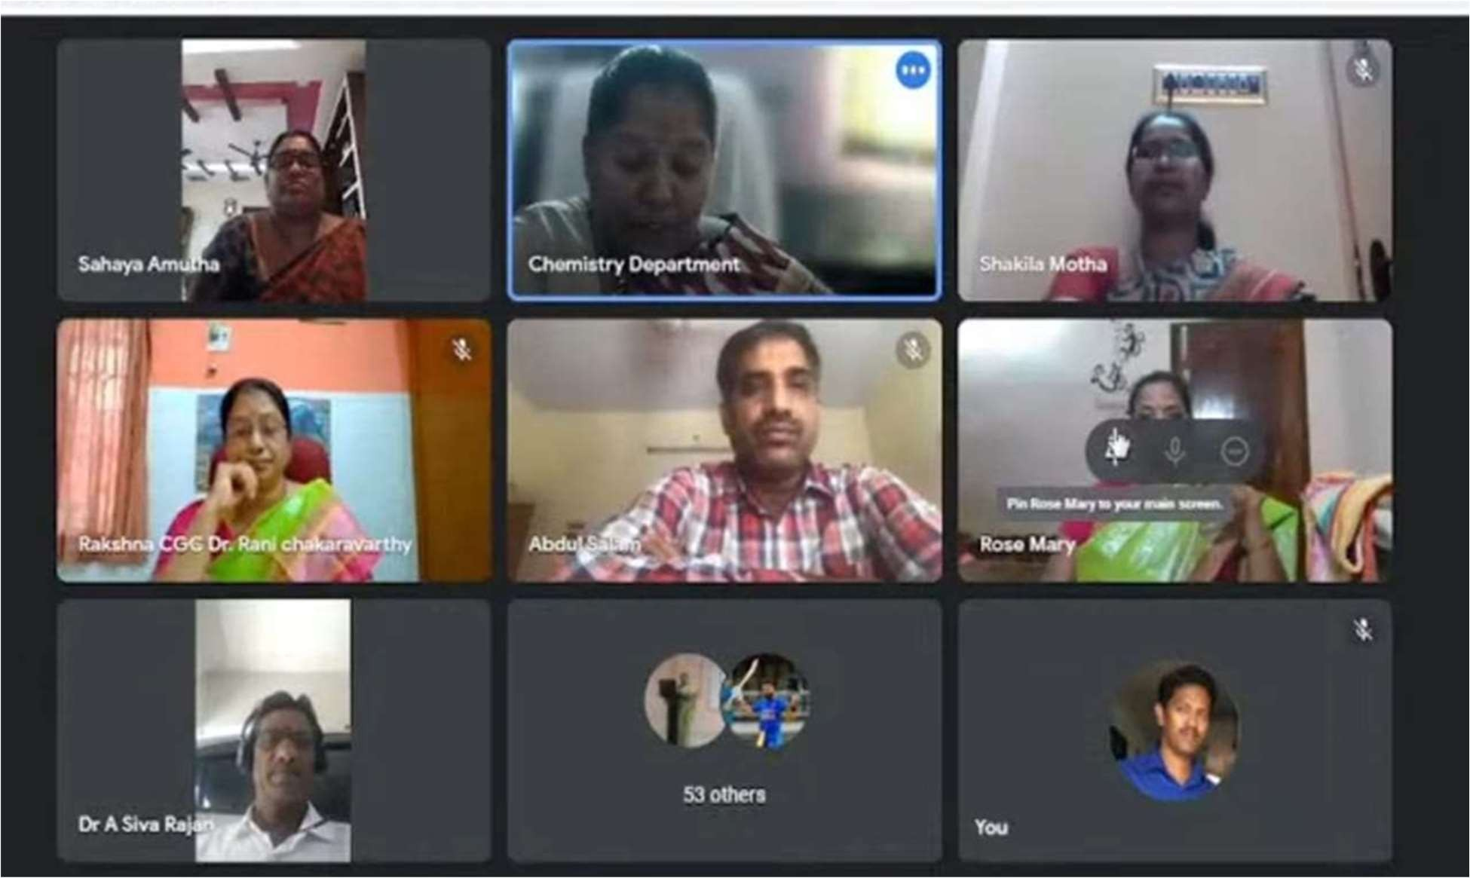

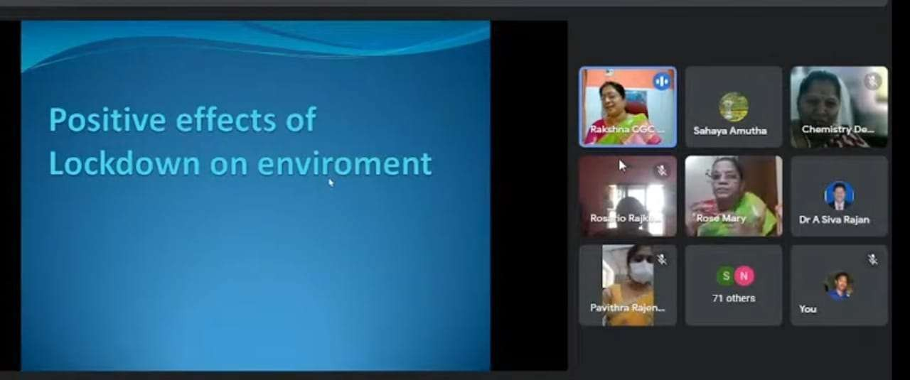

The PG & Research department of chemistry and IQAC Government Arts College, Trichy-22 organized a one day national webinar on “NMR spectral applications of organic compounds” on 29.07.2021 with a aim of imparting knowledge on nuclear magnetic resonance spectroscopy-a major analytical tool for structural studies foe chemists. Target participants include Post graduate students, Research scholars and Faculty members of Chemical sciences. Dr. S. S. Rose Mary, The Principal, presided over the function and Dr. A. Sivarajan, Head of the department of chemistry welcomed the gathering. Dr. B. Ramkumar proposed the vote of thanks. Dr. B. Ramkumar, Assistant professor of chemistry and Dr.S. Senthil Sivakumar, Assistant Professor of Chemistry were the organizing secretaries and they meticulously organized the webinar in a cohesive and interactive manner.

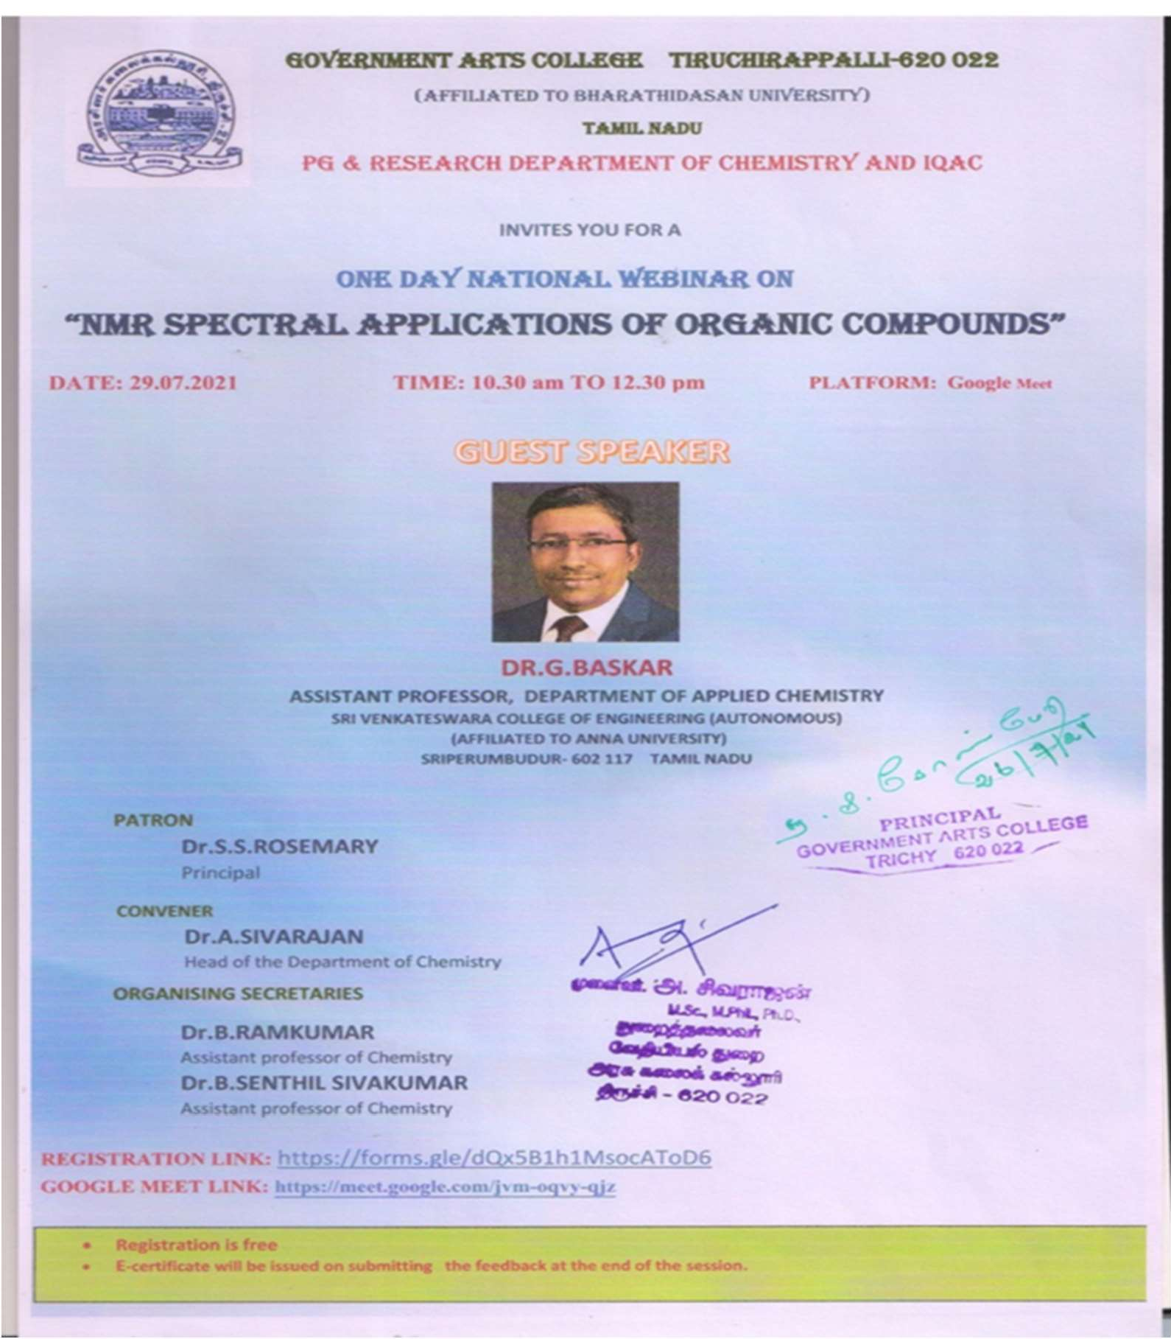

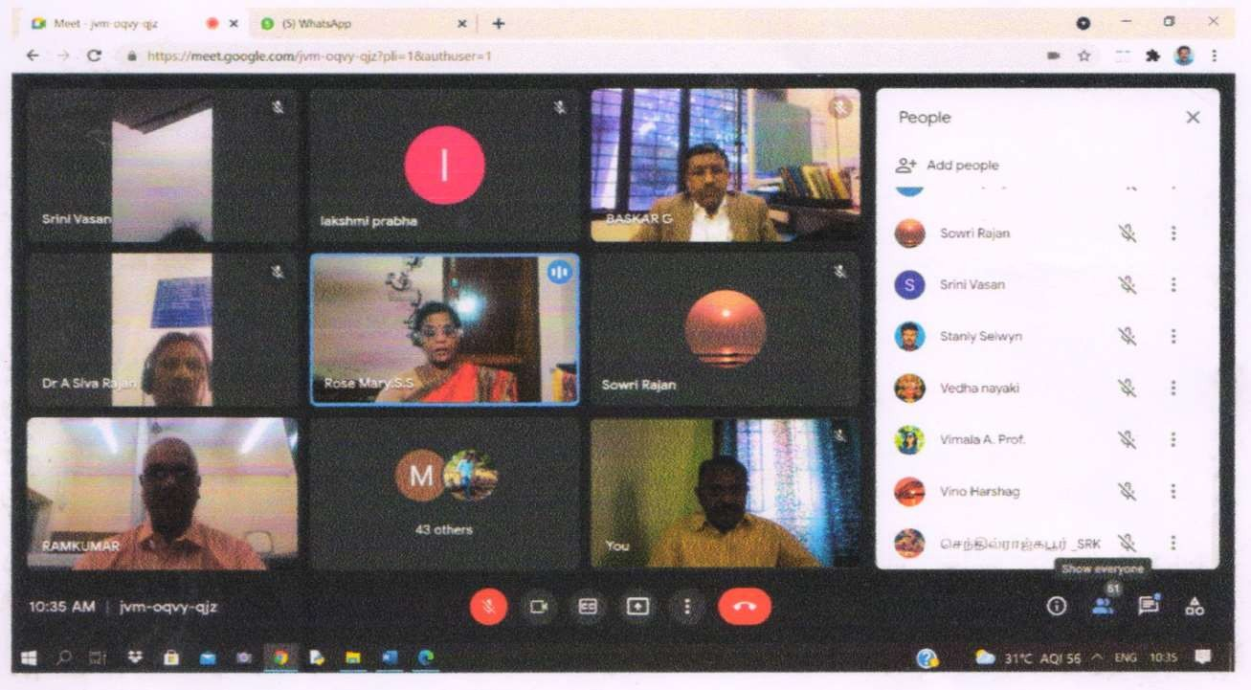
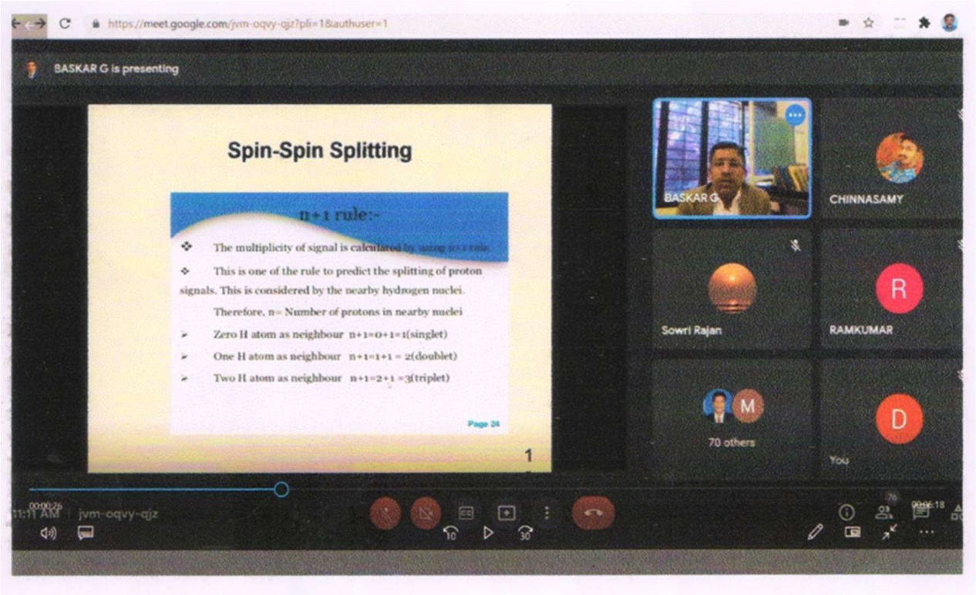
Dr. G. Baskar, Assistant professor, Department of Applied Chemistry, Sri Venkateswara college of Engineering, Pennalur, Sri Perumbudur, the Resource person of the webinar enlightened the participants with the theoretical aspects of NMR and expounded its applications especially to the organic compounds with illustrations.

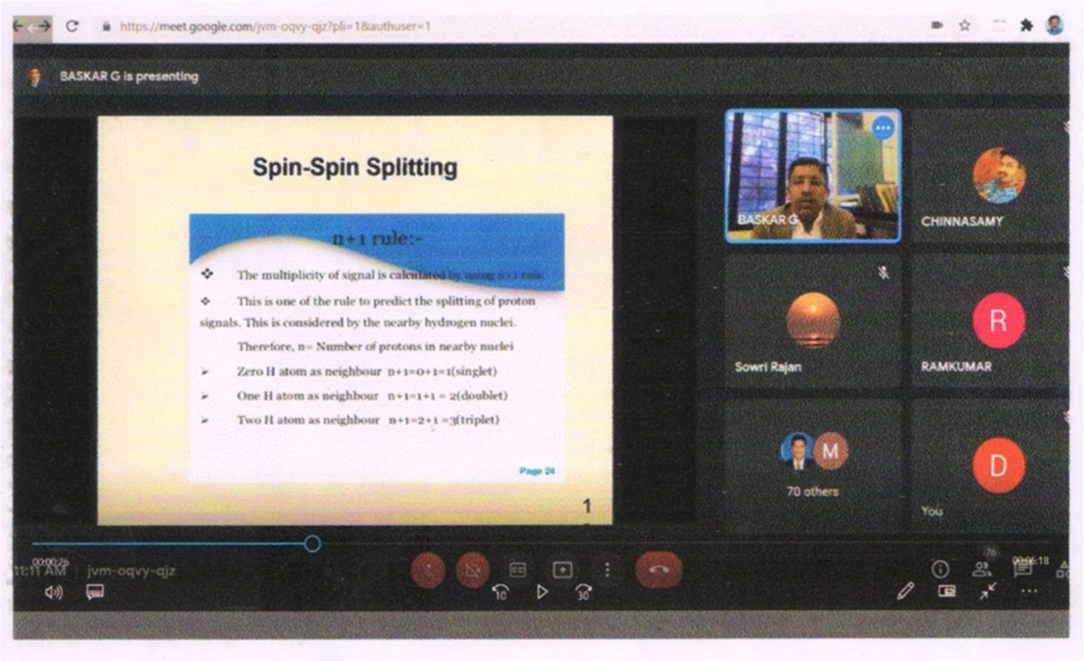
Nearly 100 participants including students, Research scholars and Faculty members of various educational institutions over all India participated in the webinar and benefited. The feedback of participants revealed that the programme was much useful and informative.

Learning Research Centre and IQAC Government Arts College, Trichy - 620022 jointly organized a National Level Webinar on “Digital Repositories: New Navigation Tools for Online Education” by Google Meet. The Webinar was held on 22-06-2021 (Tuesday) at 11.00 am.
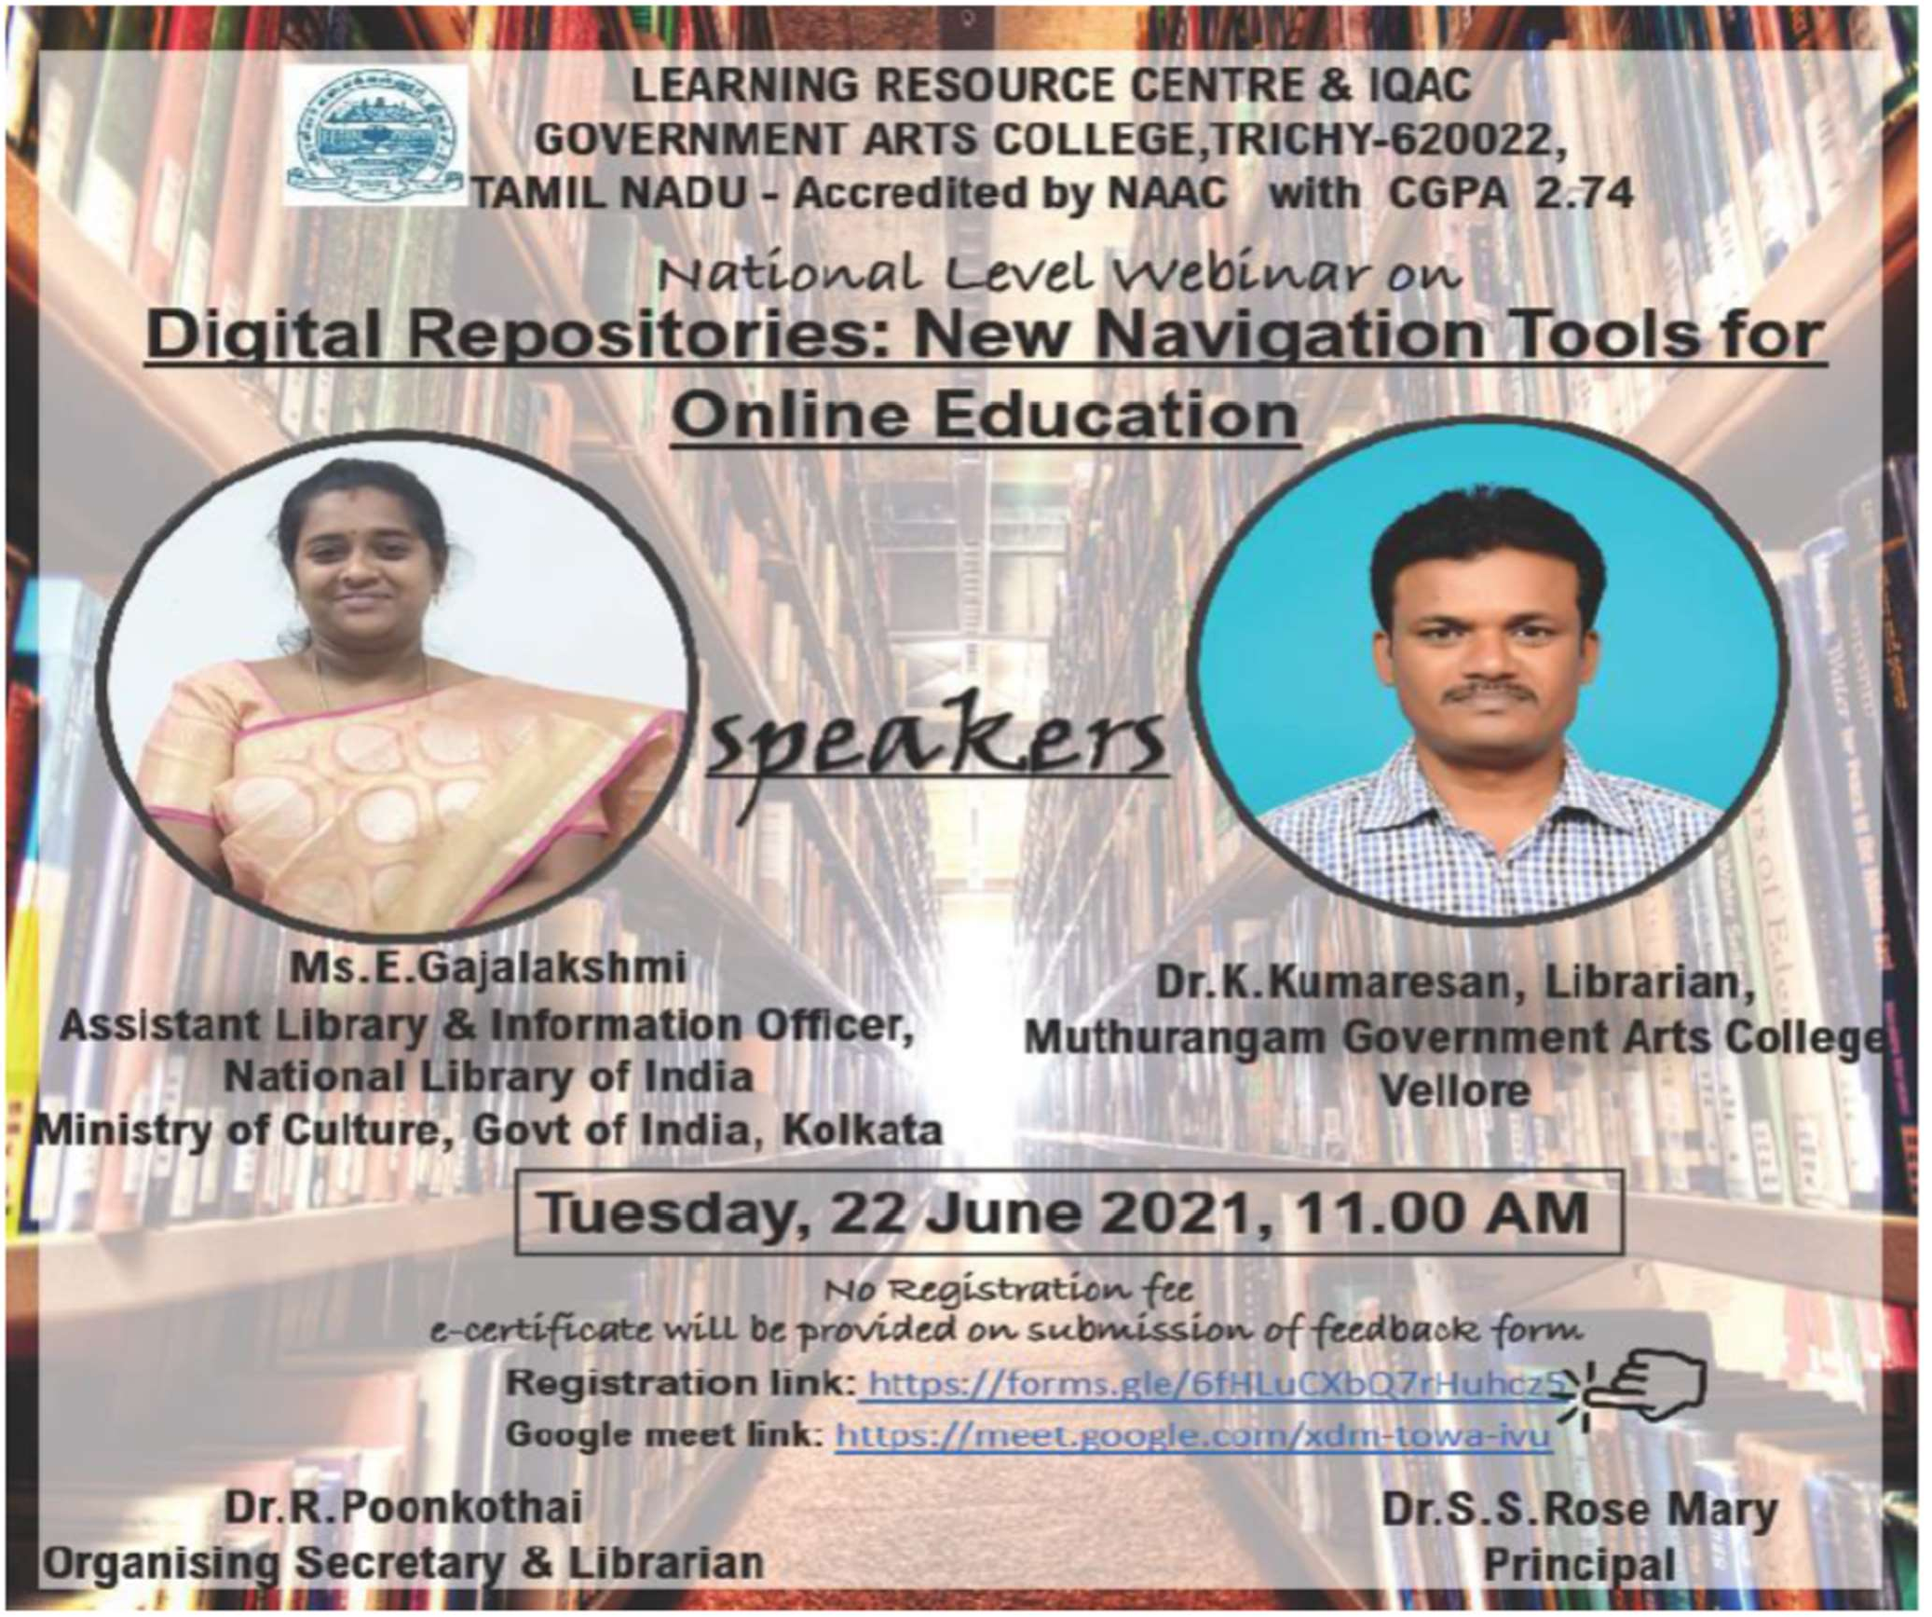

The Google Meet Link: https://meet.google.com/xdm-towa-ivu; The You TubeLink: first part of the webinar can be viewed at https://youtu.be/2nNU2dGca7c and second part of the seminar can be viewed at https://youtu.be/zxieKigjYac. Dr. R. Poonkothai, Organizing Secretary & College Librarian has organized and successfully completed the webinar.

STATE LEVEL WEBINAR:

Learning Research Centre and IQAC Government Arts College, Trichy - 620022 jointly organized a State Level Webinar on “State Level Webinar on Sexual Harassment of women at workplace- Prevention, Prohibition, Redressal” by Google Meet. The Webinar was held on 19-06-2021 (Saturday) at 09.30 am. The Google Meet Link: https://meet.google.com/vnx-xpmi-wbj; The You Tube Link: webinar can be viewed at https://youtu.be/H6r9i1lNZyQ.
Dr. R. Poonkothai, Organizing Secretary & College Librarian has organized and successfully completed the webinar.

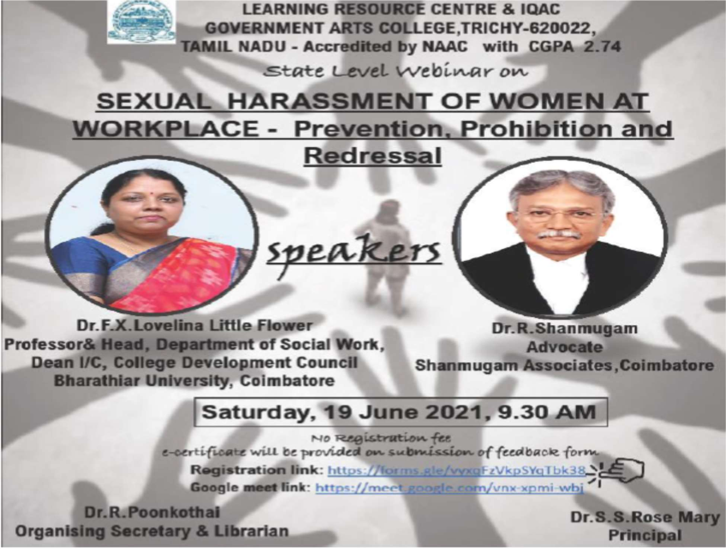

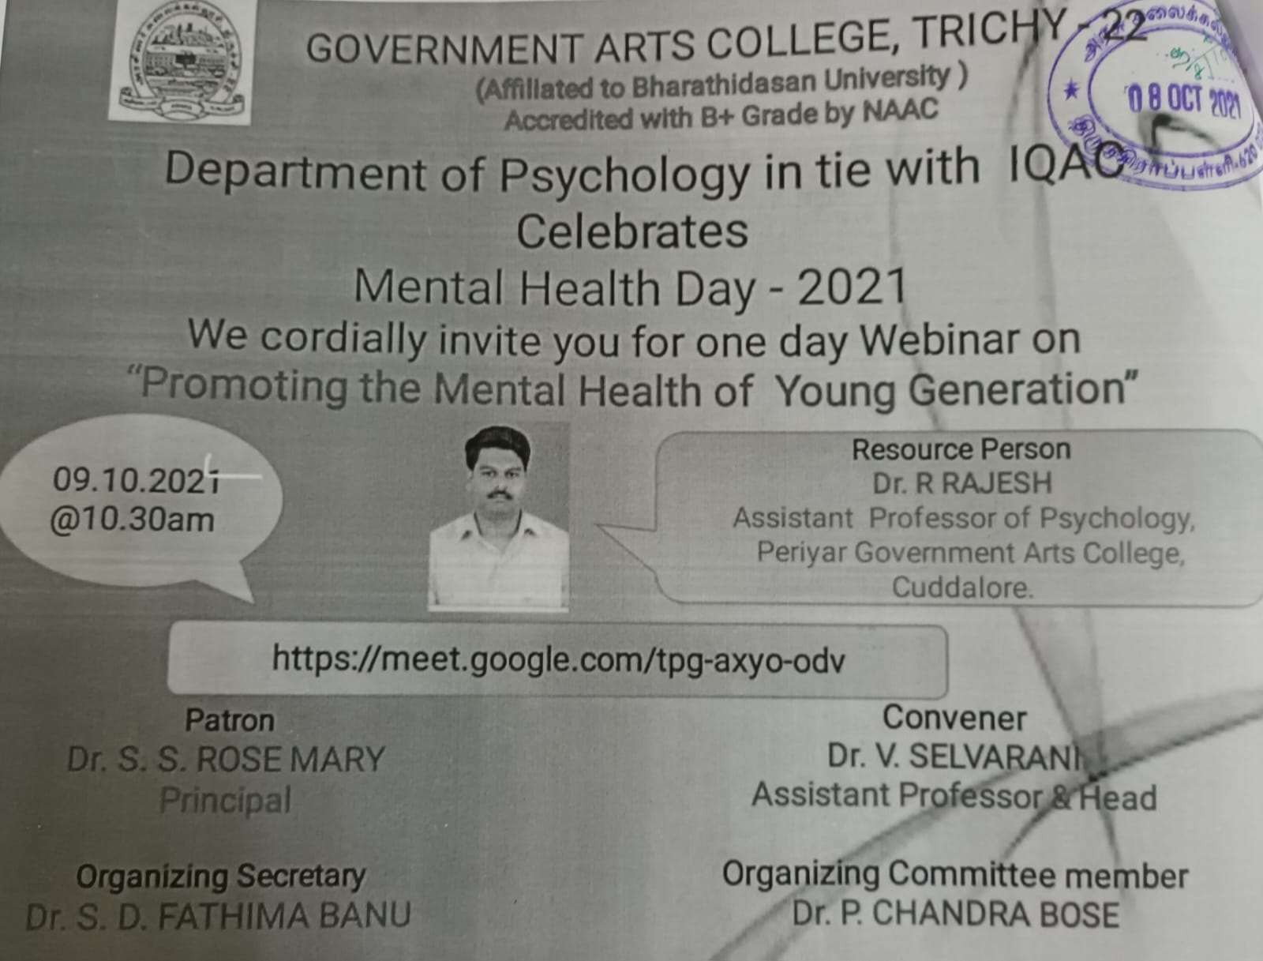
The Webinar started Dr. S. V. Selvarani, Coordinator of Psychology welcomed the gathering, Dr. S. S. Rose Mary, Principal, Government Arts College, Trichy-22 delivered the presidential address. Dr. S. D. Fathima Banu, Department of Psychology, Government Arts College, Trichy-22 Organizing Secretary of the webinar presented the theme of webinar and introduced the Chief Guest Dr. R. RAJESH, Assistant Professor of Psychology, Periyar Government Arts College, Cuddalore.

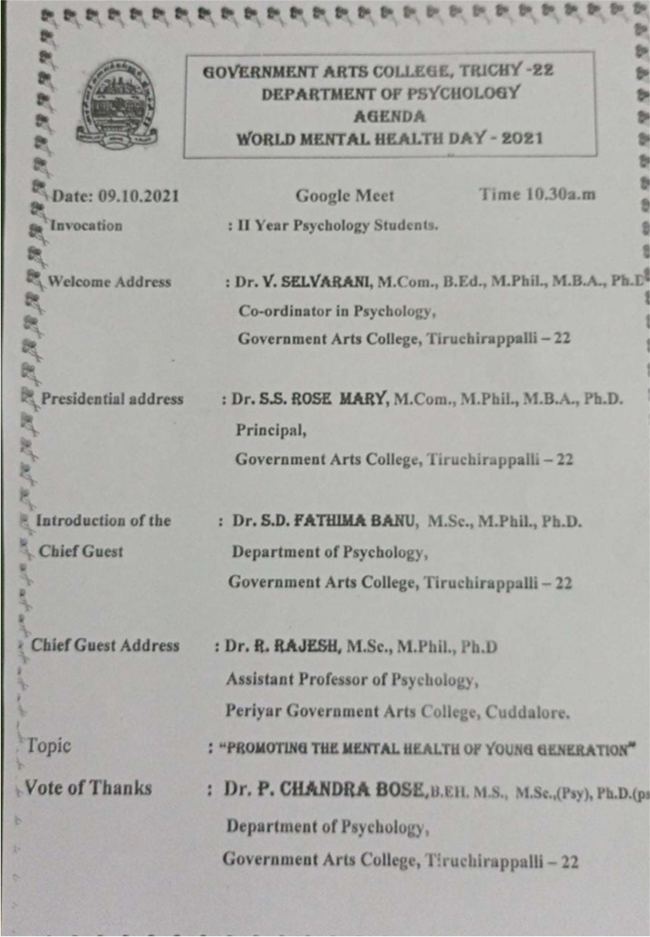

The Resource Person delivered lectures on the topic “Promoting the Mental Health of Young Generation” on Google Meet Platform. Finally
Dr. P. Chandra Bose, Department of Psychology, Government Arts College, Trichy-22 gave vote of thanks.

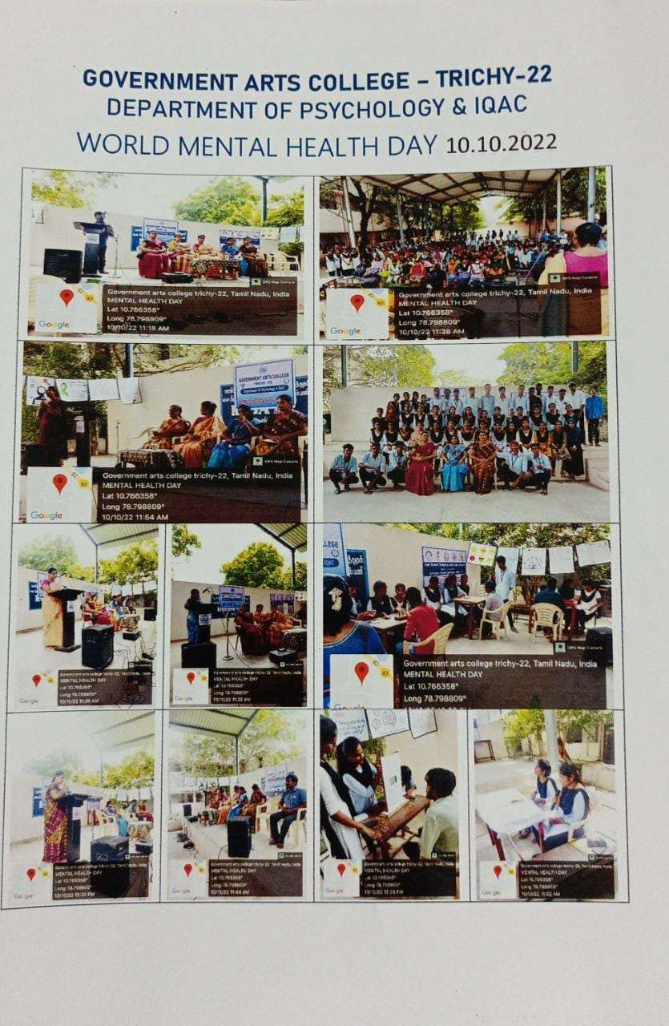

AQAR Submission
AQAR for the year 2020-2021 was submitted to NAAC, Bangalore on 29.07.2022.

IQAC Meetings
The IQAC had regular meetings with the members of each department, External Experts, parents Teachers and Alumni representatives.
Right from the inception, IQAC has been committed towards internalization and institutionalization of quality enhancement initiatives and has always been an integral part in developing a system for conscious, consistent and catalytic improvement in the overall performance of the College by helping the institution in planning and monitoring. IQAC also gives stakeholders including Students, Teachers, Parents, Alumni, funding agencies and Community, a cross- sectional participation in the institution’s quality enhancement activities.
*****

